**BuyMe**

**Cheok Li Li**

**UNIVERSITI TEKNIKAL MALAYSIA MELAKA**

**BORANG PENGESAHAN STATUS TESIS**

JUDUL: BuyMe

SESI PENGAJIAN: 2015/2016

Saya CHEOK LI LI

mengaku membenarkan tesis (PSM/Sarjana/Doktor Falsafah) ini disimpan di Perpustakaan Fakulti Teknologi Maklumat dan Komunikasi dengan syarat-syarat kegunaan seperti berikut:

1. Tesis dan projek adalah hakmilik Universiti Teknikal Malaysia Melaka.
2. Perpustakaan Fakulti Teknologi Maklumat dan Komunikasi dibenarkan membuat salinan untuk tujuan pengajian sahaja.
3. Perpustakaan Fakulti Teknologi Maklumat dan Komunikasi

dibenarkan membuat salinan tesis ini sebagai bahan pertukaran antara

institusi pengajian tinggi.

1. ** Sila tandakan (/)

SULIT (Mengandungi maklumat yang berdarjah keselamatan atau kepentingan Malaysia seperti yang termaktub di dalam AKTA RAHSIA RASMI 1972)

TERHAD (Mengandungi maklumat TERHAD yang telah ditentukan oleh organisasi/badan di mana penyelidikan dijalankan)

TIDAK TERHAD

_________________________ _________________________

(TANDATANGAN PENULIS) (TANDATANGAN PENYELIA)

Alamat tetap: ______________ _________________________

__________________________ Nama Penyelia

__________________________

Tarikh: _______________ Tarikh: __________________

CATATAN: * Tesis dimaksudkan sebagai Laporan Akhir Projek Sarjana Muda (PSM) ** Jika tesis ini SULIT atau TERHAD, sila lampirkan surat daripada pihak berkuasa

## DECLARATION

**I hereby declare that this project report entitled**

**BuyMe**

**is written by me and is my own effort and that no part has been plagiarized without citations.**

**STUDENT : ___________________________ Date : ________________**

**(CHEOK LI LI)**

**SUPERVISOR : ____________________________ Date : ________________**

**(DR MASSILA KAMALRUDIN)**

## ACKNOWLEDGEMENTS

I would like to dedicate thousands of thanks to my supervisor, Dr Massila Kamalrudin for the guidance an assistant to complete this project successfully. Throughout this process of learning, I gained a lot of valuable knowledge. I am appreciate for what Dr Massila has been guided throughout this semester.

I would also like to thank my beloved parents and friends who have been giving me support and motivation throughout my project.

## ABSTRACT

Nowadays, an online selling can be seen in many websites, the user makes their own business by using those websites to sell their products and earn some money. With this trend, the idea of BuyMe is produced. BuyMe is a selling platform for local producers to promote and sell their local product. The local producer who acts as an administrator can manage their business via this platform. This platform provides the services like add the local products’ store, description, price and other related information. The local producer will handle their local products’ business in an easier way by using this platform. On the other hand, this project also develops in mobile application which runs on Android environment. The mobile application is mainly develop for the user to make their order of the local products from local producers. The order process is not involved any online payment service. The target user for this project is outsider (people who travel to Melaka) and out state people (those who desired to buy the Melaka product). These two target users always encounter the problems such as they do not know where to buy the local products when they visit/travel to Melaka. They need to search through many websites or ask local people to find the location of the Melaka local products shops.

## TABLE OF CONTENTS

DECLARATION I

ACKNOWLEDGEMENTS II

ABSTRACT III

TABLE OF CONTENTS IV

LIST OF TABLES VIII

LIST OF FIGURES X

CHAPTER I 1

INTRODUCTION 1

1.1 Project Background 1

1.2 Problem Statement(s) 2

1.3 Objective 3

1.4 Scope 3

1.5 Project Significance 4

1.6 Expected Output 4

1.7 Conclusion of Chapter I 4

CHAPTER II 5

LITERATURE REVIEW AND PROJECT METHODOLOGY 5

2.1 Introduction 5

2.2 Facts and Findings 5

2.2.1 Domain 6

2.2.2 Existing System 6

2.2.3 Technique 12

2.3 Project Methodology 19

2.4 Project Requirements 21

2.4.1 Software Requirements 21

2.4.2 Hardware Requirements 21

2.4.3 Other Requirements 21

2.5 Project Schedule and Milestones 22

2.6 Conclusion of Chapter II 23

CHAPTER III 24

ANALYSIS 24

3.1 Introduction 24

3.2 Problem Analysis 24

3.3 Requirement Analysis 27

3.3.1 Data Requirement 27

3.3.2 Functional Requirement 28

3.3.3 Non-functional Requirement 39

3.3.4 Others Requirement 40

3.4 Conclusion of Chapter III 41

CHAPTER IV 42

DESIGN 42

4.1 Introduction 42

4.2 High-Level Design 42

4.2.1 System Architecture 42

4.2.2 User Interface Design 45

4.2.2.1 Navigation Design 45

4.2.2.2 Input and Output Design 46

4.2.3 Database Design 66

4.2.2.1 Conceptual and Logical Database Design 66

4.3 Detailed Design 71

4.3.1 Physical Database Design 71

4.4 Conclusion of Chapter IV 75

CHAPTER V 76

IMPLEMENTATION 76

5.1 Introduction 76

5.2 Software Development Environment Setup 76

5.3 Software Configuration Management 78

5.3.1 Configuration Environment Setup 78

5.3.2 Version Control Procedure 79

5.4 Implementation Status 80

5.5 Conclusion of Chapter V 81

CHAPTER VI 82

TESTING 82

6.1 Introduction 82

6.2 Test Plan 83

6.2.1 Test Organization 83

6.2.2 Test Environment 84

6.2.3 Test Schedule 84

6.3 Test Strategy 85

6.3.1 Classes of tests 86

6.4 Test Design 88

6.4.1 Test Description 88

6.4.2 Test Data 94

6.5 Test Results and Analysis 101

6.6 Conclusion of Chapter VI 108

CHAPTER VII 109

CONCLUSION 109

7.1 Introduction 109

7.2 Observation on Weakness and Strengths 109

7.3 Propositions for Improvement 110

7.4 Project Contribution 111

7.5 Conclusion 111

REFERENCES 112

APPENDICES 114

A1: Interview Survey (Stakeholder => local product seller) 114

A2: Questionnaire Survey (Stakeholder => visitor/native) 118

## LIST OF TABLES

Table 1: Advantages and limitation of existing system 10

Table 2: Compare with existing system 11

Table 3: Project Schedule 22

Table 4: Project Milestone 23

Table 5: Comparison between existing system and developed system 26

Table 6: Functional Requirement 38

Table 7: Non-functional requirements 39

Table 8: Software requirements 40

Table 9: Hardware requirements 41

Table 10: Data dictionary of user entity 68

Table 11: Data Dictionary of address entity 68

Table 12: Data Dictionary of category entity 69

Table 13: Data dictionary of shop entity 69

Table 14: Data dictionary of shop entity 70

Table 15: Data dictionary of cart entity 70

Table 16: Data dictionary of order entity 71

Table 17: Hardware Configuration 77

Table 18: Proposed version for BuyMe 79

Table 19: Implementation status for each module 80

Table 20: Test schedule 85

Table 22: Classes of test (White-box) 86

Table 21: Classes of test (black-box) 87

Table 23: Admin User Test Cases 89

Table 24: Seller Test Cases 91

Table 25: User Test Cases 93

Table 26: Admin Test Data 95

Table 27: Seller Test Data 98

Table 28: User Test Data 100

Table 29: Admin Test Result 102

Table 30: Seller Test Result 104

Table 31: User Test Result 106

## LIST OF FIGURES

Figure 1: Online Jewellery System (OJS) – home site 7

Figure 2: Online Clothes Shopping System (OCSS) – admin site 8

Figure 3: mudah.my – home page 9

Figure 4: The type of participant involved 13

Figure 5: The age range of the participant involved 14

*Figure 6: The percentage of participant experience* 15

*Figure 7: The percentage of the required function on proposed system* 16

Figure 8: The percentage of electronic device that often use 17

Figure 9: The percentage of electronic device which is preferred for ordering 18

Figure 10: The prefer ways for buying local product 18

Figure 11 : Waterfall model 19

Figure 12: Use case diagram for administrator 28

Figure 13: Use case diagram for seller 29

Figure 14: Use case diagram for customer 30

Figure 15: User Login Activity Diagram 31

Figure 16: User Logout Activity Diagram 31

Figure 17: User Register Activity Diagram 32

Figure 18: Admin Manage Category Activity Diagram 32

Figure 19: Admin Block Product Activity Diagram 33

Figure 20: Admin Unblock Product Activity Diagram 33

Figure 21: Seller Manage Product Activity Diagram 34

Figure 22: Seller Update Order Status Activity Diagram 34

Figure 23: Seller Manage Profile Activity Diagram 35

Figure 24: Customer (new/registered) Use Case Activity Diagram 35

Figure 25: Three-tier architecture design for BuyMe 43

Figure 26: BuyMe Class Diagram 44

Figure 27: Navigation Design of Admin Webpage 45

Figure 28: Navigation Design of Seller Webpage 45

Figure 29: Navigation Design of Mobile User 46

Figure 30: Admin Login Page 46

Figure 31: Admin Home Page (Product’s category) 47

Figure 32: Admin Create New Category Window 47

Figure 33: Admin Validate Products Page 48

Figure 34: Admin Unblock Product Page 48

Figure 35: Admin View User List Page 49

Figure 36: User Registration (Seller/User) 49

Figure 37: User Login Page 50

Figure 38: Seller Home Page (Manage Product) 50

Figure 39: Add New Product Page 51

Figure 40: Edit Product Page 51

Figure 41: Customer Order Page 52

Figure 42: View Customer Order Detail Page 52

Figure 43: Seller Profile Page 53

Figure 44: User Main Page 53

Figure 45: Product Detail Page 54

Figure 46: User Cart Page 54

Figure 47: User Checkout Page 55

Figure 48: User Order List Page 55

Figure 49: User Order Detail Page 56

Figure 50: User Profile Page 56

Figure 51: User Change Email Window 57

Figure 52: User Change Password Window 57

Figure 53: BuyMe Home Screen 58

Figure 54: BuyMe Product Detail Screen 58

Figure 55: Menu Screen before User Login 59

Figure 56: BuyMe Login Screen 59

Figure 57: Forgot Password Screen 60

Figure 58: BuyMe User Sign Up Screen 60

Figure 59: Menu Screen after User Login 61

Figure 60: BuyMe Cart Screen 61

Figure 61: Cart Information Screen (for updating the quantity and choose delivery service) 62

Figure 62: BuyMe Checkout Screen 62

Figure 63: BuyMe Order Screen 63

Figure 64: Order Information Screen 63

Figure 65: User Profile Screen 64

Figure 66: Change Email and Password Screen 64

Figure 67: User View Shop Location Screen 65

Figure 68: User Navigation Function Screen 65

Figure 69: BuyMe ERD 66

Figure 70: The percentage of result for Admin Test Cases 102

Figure 71: The percentage of result for Seller Test Cases 105

Figure 72: The percentage of result for User Test Cases 107

Figure 73: The Melaka durian puff owner and me 114

Figure 74: TS Lim Trading owner and me 116

# CHAPTER I

## INTRODUCTION

### Project Background

Malacca (*Malay: Melaka*), is known as a historic state in Malaysia. It is one of the most popular tourist regions in Malaysia. According to Chief Minister Datuk Seri Idris Haron (2014), he stated that the number of visitors who visited to Malacca has increased by 5.03 per cent as compared to previous year (2013). There are around 15.4 million tourists visited to Malacca in 2014, with 26 per cent of foreign tourists. The majority of the foreign tourists are from Mainland China, Singapore, Indonesia, Taiwan and Hong Kong.

Malacca not only has numerous historical and famous scenic spot, but also has many delicious and special Malacca’s local products. Malacca’s local product defined as the product that is locally or originally made in Malacca. Most of the foreign tourist, even the natives are unfamiliar with some Malacca local products. Sometimes, they overlook some of the popular local products beside the roads or elsewhere in Malacca. Furthermore, the foreign tourists also not knowing where can buy certain special local product as souvenir for the Malacca trip. Therefore, a mobile application named “BuyMe” has been developed to overcome these problems.

BuyMe is a very helpful application for the foreign visitors or local people. It provides the information of local product that sells in Malacca, as well as the information of the owner. For the user who wants to buy the local product their self instead of delivery, the user can get navigation direction (from their current location to the specific shop) via the owner’s information. Other than that, BuyMe also helps local producer to promote their stuff in an easier way. The local producer can manage their shop and products in BuyMe administration web-based system.

### Problem Statement(s)

One of the main problems is the foreign visitor may not know the popular and special local product in Malacca. They have no idea where to buy if they are travelling to Malacca on their own. Sometimes, even the natives also not clear about the particular local product sells in Malacca, and for this reason, the native cannot gives the exact location of the shop to the foreign visitor. The visitor needs to browse many sources such as travel magazine, website and blog for getting the information of the famous local product and also the location of the shop that sells it.

Apart from the problem encountered by the visitors, the local producer also has the difficulties when promoting their stuff (local product). They usually promote their stuff by friends, social network like Facebook or any online shopping websites. They do not have a selling platform for them to sell their local product officially. In addition, their shop’s location even just knows by a small group of people, for outsider, who is from other state; sometimes the outsider do not know where to buy the local products, unless get the information of the shop that sell local product from their friends or Google.

### Objective

The objectives of this project are:

1. **To provide the shop’s location for visitor**

The local producer who acts as an administrator needs to register the shop before promotes the local product by using this application. The location of the shop is the must when filling the information of the shop. Therefore, visitor who acts as a user of this application can track the location of the shop that the visitor wants to visit for buying the local product.

1. **To provide a selling platform for local producer to manage their business**

This system is basically creates for the local producer to manage the shop, products and orders. This system helps the local producer to save and edit the shop’s information and local products’ information. The local producer can view the order list which shows the details of the customer orders and update the status.

### Scope

The scope of this project focuses on:

1. Location: Melaka only
2. Target user: foreign visitor (someone who travel to Melaka / those who desired to buy the Melaka local product).
3. BuyMe will develop in Android platform only.

### Project Significance

The local producer can promote all their local product of Melaka with the use of this website in a faster and easier way. The stuff that sells by the local producer will display in BuyMe mobile application and get to know by others. Other than that, visitor can navigate to the location of the shop that selling the particular local product in a more convenient way. The navigation gives the benefits of saving time.

### Expected Output

At the end of this development, a mobile application, called BuyMe will produce. BuyMe acts as selling system to promote the local product for many more people (visitor). This android application provides clear and exact information of the local product for visitor. Visitor can order the product and make payment via this application without visit to the shop. Visitor also can track the location of the shop if the visitor desires to buy the local product by their own. In addition, BuyMe also categories the local product into few types for easier the visitor to search.

### Conclusion of Chapter I

The summary of this chapter is BuyMe can be used by all Malacca local producer who has the responsible to promote the local product of Malacca for outstate people or visitors. This application also gives advantages to visitor to know the location of the shop that sell the local product, and the information of the local product in Melaka. The next chapter will described the literature review about the existing system and the methodology used in this project.

# CHAPTER II

## LITERATURE REVIEW AND PROJECT METHODOLOGY

### Introduction

In this chapter, the facts and finding, literature review of this project, as well as the project methodology will be discussed. Facts and finding section mentioned the comparison of strength and weakness among the existing systems. The purpose of literature review is to find relevant data to support this project topic. The selected approach and techniques that used in this project will be described in project methodology part. Besides, this chapter also defined the project requirements such as software requirement, hardware requirement and other requirements. Project schedule and milestones also defined and attached in this chapter.

### Facts and Findings

This section will discuss the previous similar software project, comparison among the existing projects and the techniques use to gather the related information about this project.

#### Domain

This project is classified as web-based information system (WBIS). For this type of information system that uses Internet web technology, the information and services are delivered to user or other information system / application. It gathers, stores, collects and communicates data from different sources and spread information at the glance. The front-end of this project is web browser and mobile application while the back-end is database. The user manages the database via front-end without open the online database software system. All the database compilation runs through front-end.

#### Existing System

This project is developed in web-based information system which the user will manage all the required data in web-based system and these data will distribute via online database to mobile application for the usage like view and read by other users.

This project is nearly similar to e-commerce system. According to Mark van Ketel and Tim D.Nelson (2005), e-commerce also called electronic commerce or EC, is the trading or funds transmitting over Internet. This online business transaction becomes popular nowadays. People are more interested in buying their desires product online as all the related information is provided in the specific websites. There are many similar projects which have been developed by other researches.

1. **Online Jewellery Shopping (OJS)**

One of the previous projects is Online Jewellery Shopping (OJS). This project is developed by Nikul Patel and Nitin Patel (2010) with the main idea of replacing the manual work on the paper in Jewellery shop. It is a web based application that provides the information of the license jewellery company and the jewellery details. There are two modules in this system, admin module and user module. Admin can manage the user account, Jewellery, orders, feedback and generate the sales report. The unregister user can view and search all the jewellery’s information that sell in the specific company, whilst the registered user can make order and payment through Internet.

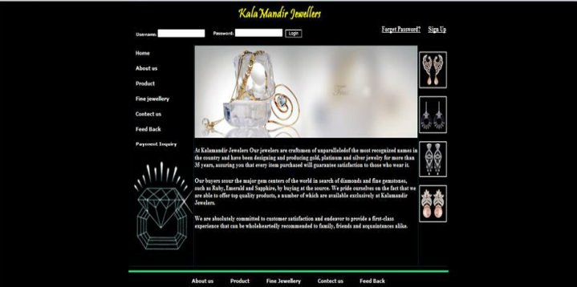

Figure : Online Jewellery System (OJS) – home site

1. **Online Clothes Shopping System (OCSS)**

The other previous system is Online Clothes Shopping System (OCSS) which is also a web based application that developed by Shivangi sethi (2014). This system helps people to find and buy the latest fashion clothes on Internet. This system consists of two modules, which are admin module and user module. Administrator is able to edit any information regarding the clothes in this application. The user for this system must have to register before access to this system, such as make online payment. An unregister user cannot access any function to this website like viewing the related clothes. Only the registered user can view the details of the clothes and purchase online.

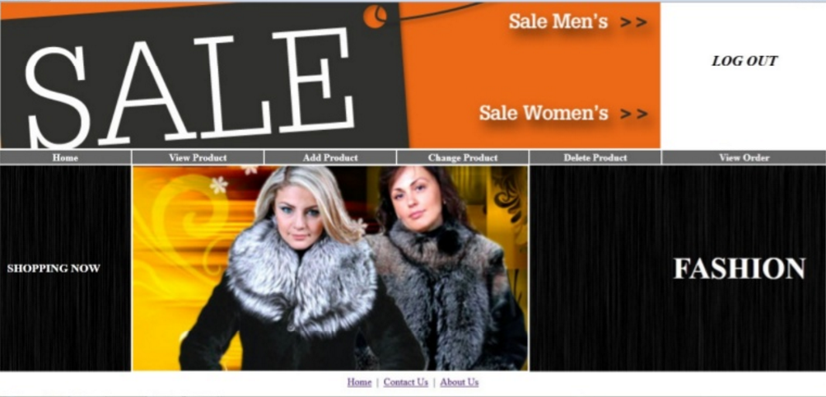

Figure : Online Clothes Shopping System (OCSS) – admin site

1. **Mudah.my**

Mudah.my is an existing website that used by nowadays user. It is an online classified-ads website for anyone to promote their stuff. This system caters principally to the Malaysian market. Anyone can sell and buy the goods according to different categories such as electronic products, clothes, and many more. The user can view the item information based on the state of Malaysia or categories. The user can also start their business by posting the free advertisements on this website. The payment method depends on the seller as this system is not provided online payment service. Mudah.my provides two ways for the buyer to deal with the seller, which are contact by phone or send email.

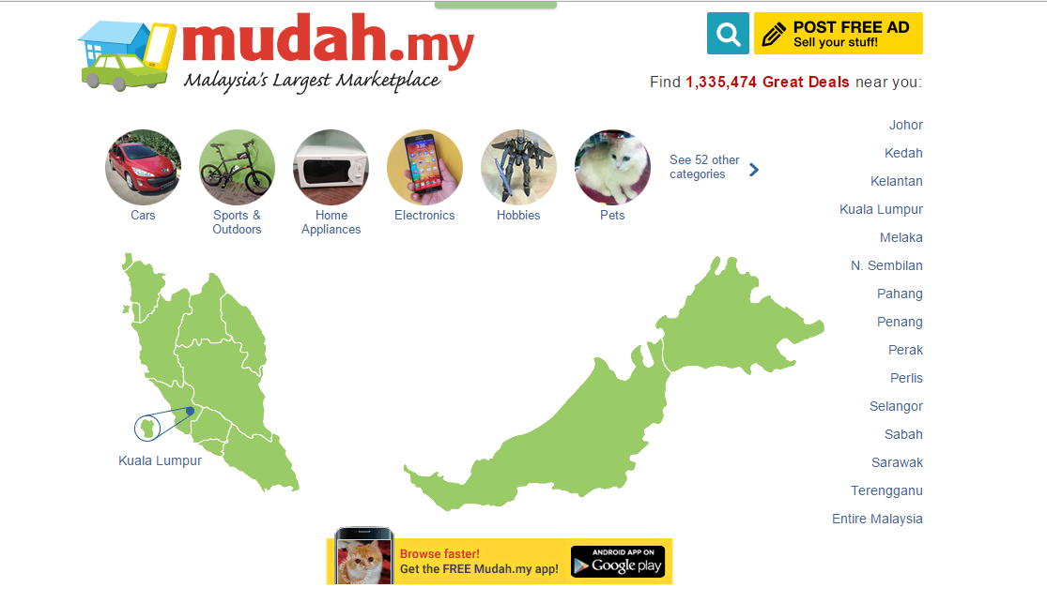

Figure : mudah.my – home page

**Advantages and Limitation of Existing System**

|  |  |  |
| --- | --- | --- |
| Existing system | Advantages | Limitation |
| Online Jewellery Shopping (OJS) | * All the information of Jewellery is described clearly. * Allow user to make online order. | The shop address is stated but it does not embedded with Google map which the user can navigate directly from the address. |
| Online Clothes Shopping System (OCSS) | * All the information of clothes is described clearly. * Allow user to make online order. | All the functions of this system can only use by registered user. |
| Mudah.my | User can search the favorite products by distinct categories or state in Malaysia. | The full owner location/address is only stated in city and state for their user. |

Table : Advantages and limitation of existing system

**Comparison of existing system**

|  |  |  |  |
| --- | --- | --- | --- |
| Function | OJS | OCSS | Mudah.my |
| Login | ✓ | ✓ | ✓ |
| Register as user | ✓ | ✓ | ✓ |
| Manage product | ✓ | ✓ | ✓ |
| Show product information | ✓ | ✓ (only for registered user) | ✓ |
| Show owner/shop information | ✓ | ✓ (only for registered user) | ✓ |
| Show shop location | ✓ |  | ✓ |
| Search product | ✓ | ✓ (only for registered user) | ✓ |
| Online order | ✓ | ✓ (only for registered user) |  |
| Update product information | ✓ | ✓ (only for registered user) | ✓ |
| Develop in mobile application |  |  | ✓ |

Table : Compare with existing system

#### Technique

To conduct this research, there are two types of data gathering techniques are used to collect customer requirements, which are interview and questionnaire. The following is the explanations of both techniques:

1. **Interview**

The stakeholder for interview is seller. There are three people selected based on the category of local product (*refer Appendix section*). The summary of the interview will discuss in the following paragraph.

Based on the interview result, the sellers promote their stuff by travel books, websites, food programs on YouTube or TV show, or even just found by any passed-by visitor. One of the interviewee faced a problem when sell the product online in one of the selling websites. The problem involved the copyright of the product design. Then, the function that interviewee suggested is add the location of the shop in the application. By using this function, the customer can choose to buy the local product at the shop or buy through this application. Other than that, the sellers are willing to deliver (for certain quantity) the product to customer.

1. **Questionnaire**

The stakeholder for questionnaire is visitor/native. There are a total of 100 people participated in this survey. A set of question is attached atAppendix section. The following is the result of the conducted questionnaire:

* Section A: Demographic Profile

Figure : The type of participant involved

The figure above shows the type of participant involved in this survey. The participant involved is either a visitor (someone who visited to Melaka) or native (someone who lived in Melaka). Both female and male is considered in this survey. There are 55% of the participant involved is visitor, where 34% of female and 21% of male.

Figure : The age range of the participant involved

The figure above shows the age range of the participant involved in this survey. The number of participant involved who is in the age range of 32 to 39 is the highest (31%) among the others, following by the age range of 24 to 31 and 18 to 24, which has 28% and 25% respectively.

* Section B: Visitor Experience

*Figure 6: The percentage of participant experience*

The figure above shows the percentage of participant experience. There are around 50% of the participants who always travel in group to Melaka. The percentage of the participant who is familiar with the Melaka local product is 24% while for the participant who is unfamiliar with it is difference around 36% more, include both native and visitor. This can be explained that most of the participants do not know the local product in Melaka even a native. Next, 55% of the participants do not done survey about the local product in Melaka before traveling, some yes. There are around 32% of the participants who will buy the local product as souvenir in the trip. Based on this survey, the participants have the difficulties in buying the local product such as no time and missing the shop that sells local product of Melaka. This can be explained from the graph above. Obviously, there are exceed 50% of the participants is disagreed with the last two statements.

* Section C: System Overview

*Figure 7: The percentage of the required function on proposed system*

The figure above shows the percentage of the required function on proposed system. The basic function suggested such as login, register as user, search the local product, bookmark the favorite product and view the location of the shop have more than 60% participants agreed with. In contrast, there are around 8% of the participants who disagreed with the order function and online payment. Besides the above functions, the extra function that commented by the participants is conversation chat between the seller and buyer.

* Section D: User Behavior

Figure : The percentage of electronic device that often use

The figure above shows the percentage of electronic device that often used by participant. The choices of electronic device in this survey are computer and smartphone. Based on the graph, the usage of smartphone in the participant involved is the highest, which is 57% compared to computer usage, which only 30%. This result indicates that the participant involved use the smartphone more often compared to computer.

Figure : The percentage of electronic device which is preferred for ordering

The figure above shows the percentage of electronic device which is preferred for ordering. There are 50% of the participants who prefer to use smartphone to order the product. 32% of the participants suggest using both electronic devices for ordering.

Figure : The prefer ways for buying local product

The figure above shows the prefer ways for buying local product. There are 55% of the participants who prefer to buy the local product at the shop instead of delivery. The percentage of the participant who chooses to delivery is only difference about 10% compared with the one who desired to buy at the shop.

### Project Methodology

The methodology that used in this project is Waterfall. This methodology is chosen for this project because it is clearer and easier to use compared to other methodology. Object-Oriented Analysis Design (OOAD) is applied in this methodology as this application will develop in Java which is a concurrent, class-based and object-oriented programming language.

The following figure shows the process of the selected methodology.



Figure : Waterfall model

At requirements analysis phase, it is essential to document all requirements from stakeholders. The techniques used (as mentioned in *section 2.2.3*) are an important and time consuming part as to analyze the customers’ problems and needs about this application. Since OOAD approach is used, some diagram such as use case diagram, class diagram and sequence diagram is needed for more understanding about this application.

At design phase, the data that need to store in the database is analyzed. After analyzed all the required data, the database design includes the entity, attribute and relationship between each entity of BuyMe application will construct. Then, all the Graphical User Interface (GUI) design of this application will construct before implementation phase.

At implementation stage, it is a coding part. The environment of the needed software for developing this application will completely set before starting the implementation part. All the required function of this application is determined in the analysis phase and will implement to the BuyMe software. Sometimes this phase is carried out with testing phase simultaneously in order to reduce the occurrence of errors in the application.

At testing phase, test case is prepared. Each test requirement will test and record in the document. Testing process will proceed until the application is lack of error.

At installation phase, a complete and functional BuyMe application will release and install in the suitable platform phone for end user to use. If any bug or error encounters when using this application, maintenance will be carried out (at the maintenance phase).

### Project Requirements

#### Software Requirements

The following are the software with it requirements that needs in this project:

* Windows Operating System Windows 10 Education
* Android Studio 2.1.1
* Adobe Dreamweaver CS5
* XAMPP Server v3.2.1
* StarUML v2.6.0
* Microsoft Visio 2010

#### Hardware Requirements

The following are the hardware with it requirement that needs in this project:

* Any smartphone with Android 4.4 KitKat and above
* Laptop

Installed memory (RAM): 8.00 GB

#### Other Requirements

Not Applicable

### Project Schedule and Milestones

This project is given 15 weeks to produce a complete application. A project schedule is prepared for ensuring that this project can work smoothly at the given time. The following shows the schedule of this project:

|  |  |  |  |  |
| --- | --- | --- | --- | --- |
| Activities | Week | Start Date | End Date | Predecessor |
| Proposal Submission | 1 | 22/02/2016 | 28/02/2016 | Proposal |
| Proposal Amendment | 2 | 29/02/2016 | 06/03/2016 | Proposal |
| Proposal Review and Chapter 1 (Introduction) | 3-4 | 07/03/2016 | 20/03/2016 | Proposal |
| Chapter 1 and Chapter 2 (Literature Review) | 5-7 | 21/03/2016 | 10/04/2016 | Proposal, Chapter 1 |
| Chapter 2 | 6-7 | 27/03/2016 | 10/04/2016 | Chapter 1 |
| Chapter 2 and Chapter 3 (Project Methodology) | 7-8 | 11/04/2016 | 24/04/2016 | Chapter 2 |
| Progress Report 1 Presentation | 8 | 25/04/2016 | 01/05/2016 | Chapter 1 – Chapter 3 |
| Demo, Chapter 3 and Chapter 4 (Algorithm Design) | 8-10 | 25/04/2016 | 15/05/2016 | Chapter 3, Chapter 4, Complete System |
| Demo and Progress Report 2 presentation | 10-11 | 16/05/2016 | 29/05/2016 | Complete System, Chapter 1 – Chapter 4 |
| Complete System Demonstration | 12 | 30/05/2016 | 30/05/2016 | Complete System |
| Final Year Project 1 Report | 13-14 | 31/05/2016 | 04/06/2016 | Final Year Report 1 |
| Presentation | 15 | 05/06/2016 | 15/02/2016 | Complete system, Final Year Project Report 1 |

Table : Project Schedule

|  |  |  |  |  |  |  |  |  |  |  |  |  |  |  |  |
| --- | --- | --- | --- | --- | --- | --- | --- | --- | --- | --- | --- | --- | --- | --- | --- |
| Week  Activities | 1 | 2 | 3 | 4 | 5 | 6 | 7 | 8 | 9 | 10 | 11 | 12 | 13 | 14 | 15 |
| Proposal Submission |  |  |  |  |  |  |  |  |  |  |  |  |  |  |  |
| Proposal Amendment |  |  |  |  |  |  |  |  |  |  |  |  |  |  |  |
| Proposal Review and Chapter 1 (Introduction) |  |  |  |  |  |  |  |  |  |  |  |  |  |  |  |
| Chapter 1 and Chapter 2 (Literature Review) |  |  |  |  |  |  |  |  |  |  |  |  |  |  |  |
| Chapter 2 |  |  |  |  |  |  |  |  |  |  |  |  |  |  |  |
| Chapter 2 and Chapter 3 (Project Methodology) |  |  |  |  |  |  |  |  |  |  |  |  |  |  |  |
| Progress Report 1 Presentation |  |  |  |  |  |  |  |  |  |  |  |  |  |  |  |
| Demo, Chapter 3 and Chapter 4 (Algorithm Design) |  |  |  |  |  |  |  |  |  |  |  |  |  |  |  |
| Demo and Progress Report 2 presentation |  |  |  |  |  |  |  |  |  |  |  |  |  |  |  |
| Complete System Demonstration |  |  |  |  |  |  |  |  |  |  |  |  |  |  |  |
| Final Year Project 1 Report |  |  |  |  |  |  |  |  |  |  |  |  |  |  |  |
| Presentation |  |  |  |  |  |  |  |  |  |  |  |  |  |  |  |

Table : Project Milestone

### Conclusion of Chapter II

For overall of this chapter, BuyMe will be built in a new and simple feature based on the existing system. It is only focused on mobile application as the mobile smartphone take over the websites gradually in the past few years. The next chapter will be described about the problem and requirement analysis of this application.

# CHAPTER III

## ANALYSIS

### Introduction

This chapter will discuss the problem and requirement analysis of this project. Problem analysis described the ways to solve the current problem that faced by user, how this application helps the user. The functional and non-functional requirements of this application also included in this chapter.

### Problem Analysis

The problem statements that mentioned in Chapter I are foreign visitor or native has difficulties in finding and knowing the local product in Malacca and there does not has an official platform for local producer to promote their stuff. There was many website or application can sell and post own products to start a small online business nowadays, however the selling area of those existing system (for example, Mudah.my) is too broad, this means that the existing system enable user to sell everything on the website or application.

In addition, the visitor is hardly to know the exact location of the special and famous local product that exists in Malacca. The visitor need to explore their self, read through many sources or sometimes, notice the local product shop by coincidence.

Therefore, BuyMe provides the solution to solve these problems. BuyMe website is mainly developed for seller to manage their shop, products and orders. The website has the function of tracking the current location of the shop. The user can save the latitude and longitude from Google map to database instead of type the shop address manually. This location information will be displayed in mobile application which embedded with navigation function. The buyer/visitor can navigate to the shop by using this function if the buyer desires to buy the local product physically.

Besides that, BuyMe has an admin to control the flow of entire system. The admin can view the number of registered websites seller and also the registered application user. The admin able to check and block any harmful product that sells by seller (user).

The following section shows the comparison of the existing system and this developed system.

**Comparison between Existing and Developed System**

|  |  |  |  |  |
| --- | --- | --- | --- | --- |
| Function | OJS | OCSS | Mudah.my | **BuyMe** |
| Login | ✓ | ✓ | ✓ | **✓** |
| Register as user | ✓ | ✓ | ✓ | **✓** |
| Manage product | ✓ | ✓ | ✓ | **✓** |
| Show product information | ✓ | ✓ (only for registered user) | ✓ | **✓** |
| Show owner/shop information | ✓ | ✓ (only for registered user) | ✓ | **✓** |
| Show shop location | ✓ |  | ✓ | **✓** |
| Search product | ✓ | ✓ (only for registered user) | ✓ | **✓** |
| Online order | ✓ | ✓ (only for registered user) |  | **✓** |
| Update product information | ✓ | ✓ (only for registered user) | ✓ | **✓** |
| Develop in mobile application |  |  | ✓ | **✓** |
| **Navigate to the desired shop** |  |  |  | **✓** |
| **Track and save the shop location (latitude, longitude) from Google map** |  |  |  | **✓** |

Table : Comparison between existing system and developed system

### Requirement Analysis

This section will provide the details of the requirement analysis for BuyMe system. The requirements include data, functional, non-functional and others that related.

#### Data Requirement

This section will describe the data that the system should input and output, as well as the data that need to store in the database.

Input Data:

* Cart information (defined by customer)
* Category information (defined by administrator)
* Orders information (defined by customer)
* Product information (defined by seller)
* Shop information (defined by seller)
* User information (defined by administrator, seller and customer)
* Address information (defined by customer and seller)

Output Data:

* Screen outputs

1. BuyMe mobile application: There will be a total of screen outputs from mobile application.
2. BuyMe admin website: There will be a total of screen outputs from website.

#### Functional Requirement

There are three types of users will utilize this system, which are administrator, seller and customer (buyer). Each of these users has the specific function in this application.

Administrator must login before accessing to this system. Administrator can manage the category of the product. This means that administrator can add, remove and modify the types of product when necessary. Otherwise, the administrator can check the suitability of the product that sold by the seller and administrator has the right to block/delete the particular invalid product. The administrator can also view the user list that contains the number of the seller and customer who register for using this application. The following figure shows the use case diagram for the administrator.

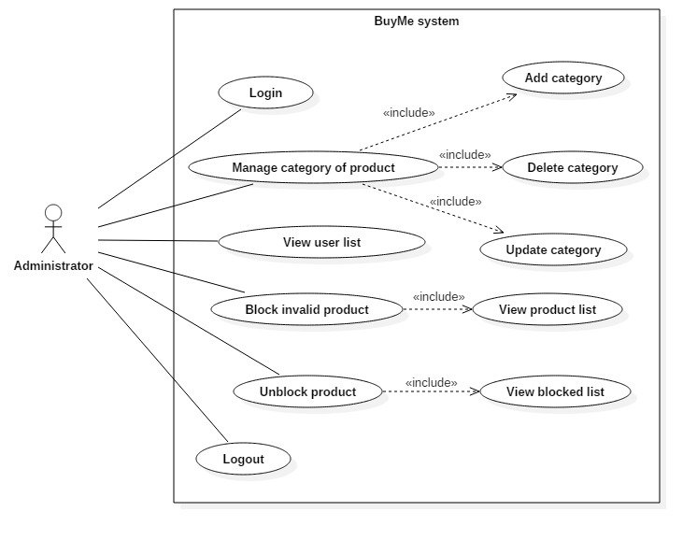

Figure : Use case diagram for administrator

Next, there are two types of seller, which are new seller and registered seller. New seller must register before using the application function that same as registered seller. The registered seller must login before using the application to sell their stuff. The registered seller can manage product. This means that the registered seller can add, delete and update the shop and product information if necessary. The seller can update profile (which includes the shop detail), the seller can update the shop information in their profile. Other than that, the registered seller can view the order list and update the order status of the product that the customer orders for delivery. The following shows the use case diagram for the seller.

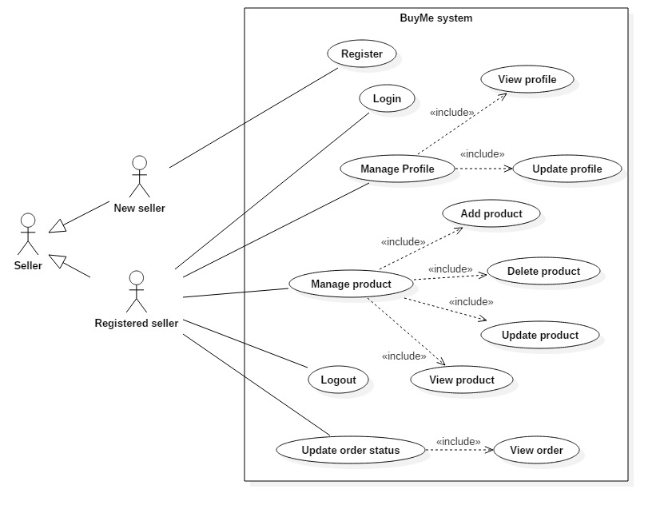

Figure : Use case diagram for seller

Last but not least, there are also two types of customers, new customer and registered customer. New customer must register as a user before making orders. The functions of ordering the selected product are only used by the registered customer, while the unregistered customer can view and search the local product according to category without login to this application or register as a user. The registered customer can also keep track the ordered product by viewing the order status. The following shows the use case diagram for customer.

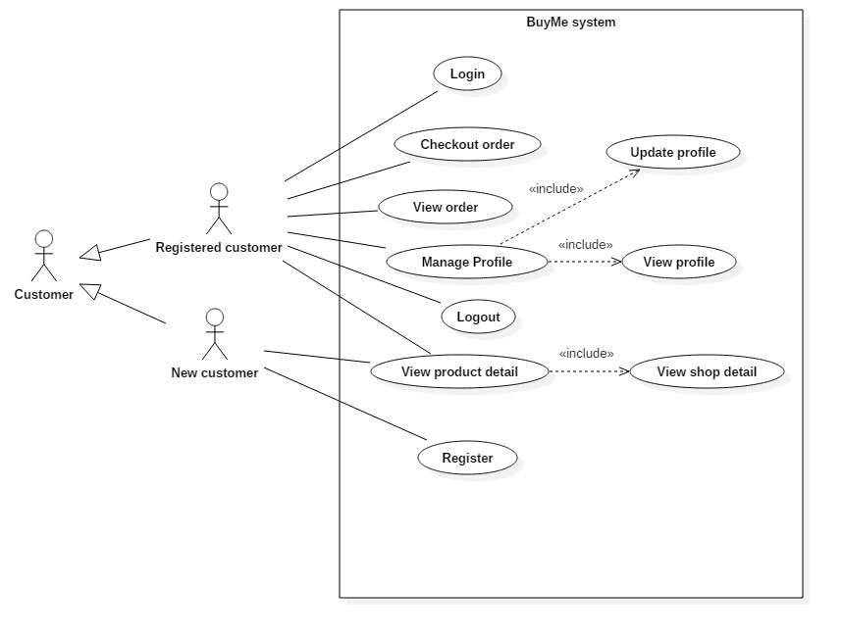

Figure : Use case diagram for customer

The figures below show the activity diagram for each use cases that stated above.

1. **Activity diagram for user (admin, seller and customer) login use case**

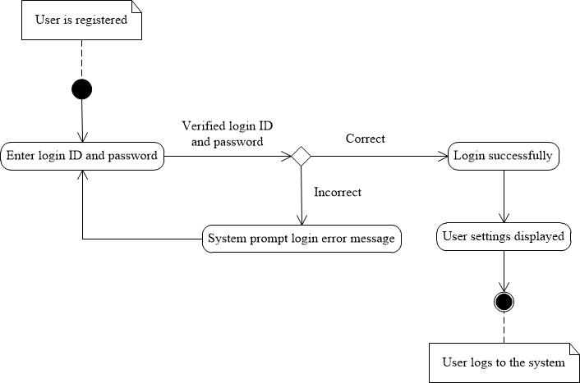

Figure : User Login Activity Diagram

1. **Activity diagram for user (admin, seller and customer) logout use case**

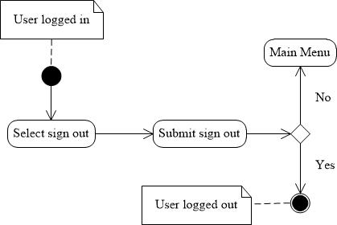

Figure : User Logout Activity Diagram

1. **Activity diagram for user (seller and customer) register use case**

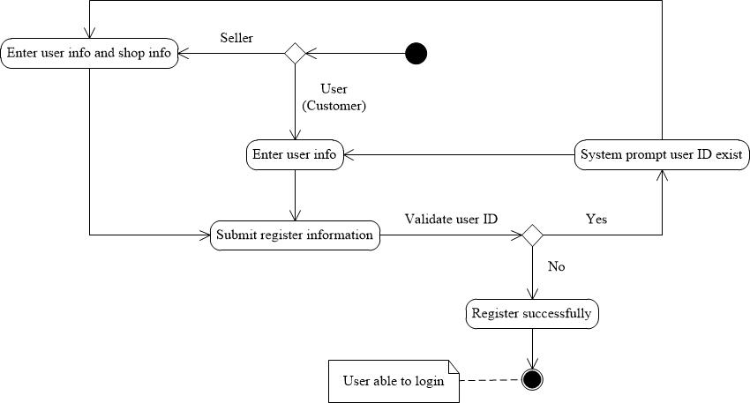

Figure : User Register Activity Diagram

1. **Activity diagram for admin manage category use case**

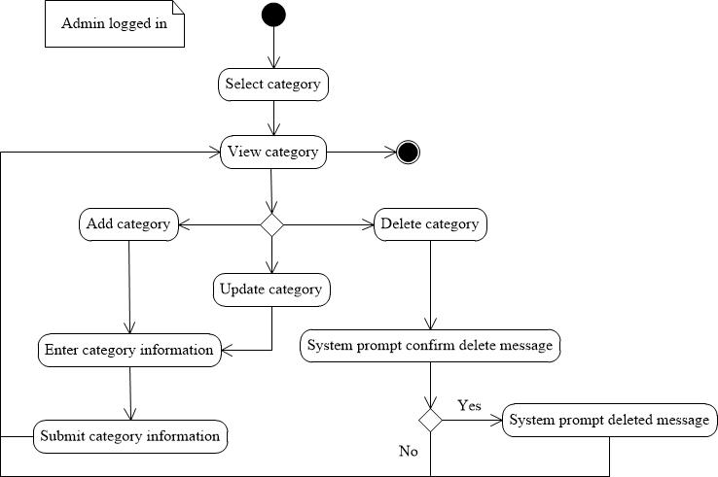

Figure : Admin Manage Category Activity Diagram

1. **Activity diagram for admin block product use case**

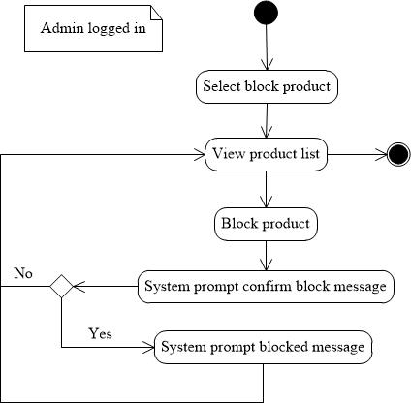

Figure : Admin Block Product Activity Diagram

1. **Activity diagram for admin unblock product use case**

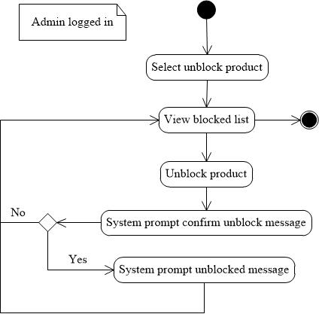

Figure : Admin Unblock Product Activity Diagram

1. **Activity diagram for seller manage product use case**

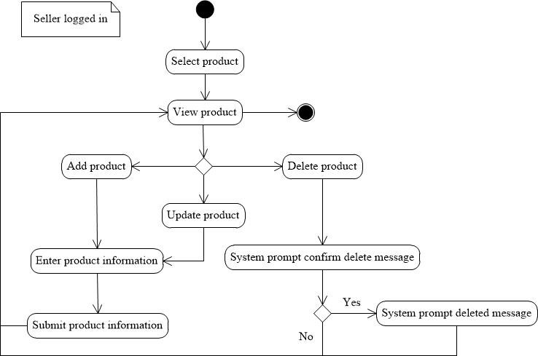

Figure : Seller Manage Product Activity Diagram

1. **Activity diagram for seller update order status use case**

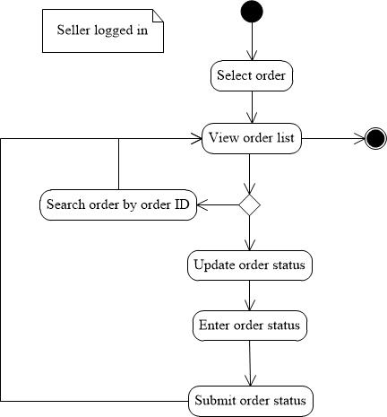

Figure : Seller Update Order Status Activity Diagram

1. **Activity diagram for seller manage profile use case**

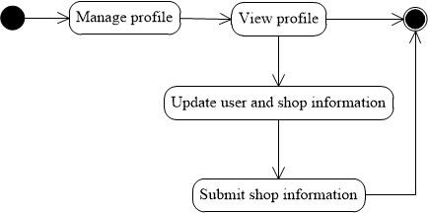

Figure : Seller Manage Profile Activity Diagram

1. **Activity diagram for customer (new/registered) use case**

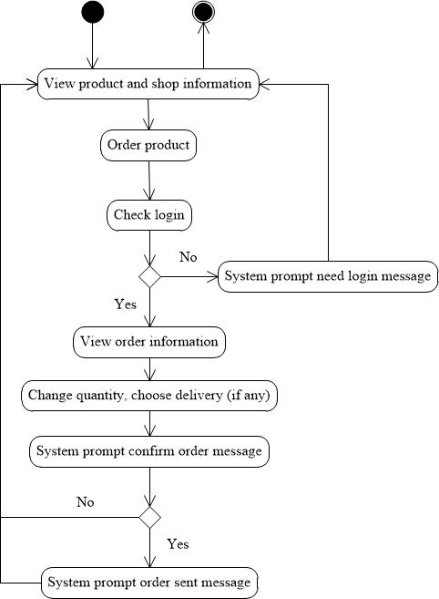

Figure : Customer (new/registered) Use Case Activity Diagram

The table below show the details of the functional requirements based on the above use cases.

|  |  |  |
| --- | --- | --- |
| **FR_NO** | **Functional Requirement** | **Description** |
| FR_NO1_1 | Login and Logout | The system will be used by seller and admin who need to login in webpage by a valid user ID and password. For customer, they can direct access the view function (view product and shop information) after install BuyMe mobile application. The customer need login for order function. |
| FR_NO1_2 | The system will verify the valid user ID and password for admin, seller and customer. |
| FR_NO2_1 | User Registration | For seller, they must register as a user for accessing all the function in BuyMe webpage to manage their own information such as shop and products. They have to register their shop before login to the system. For customer (buyer), they have to register once they do not have an account to order local product via mobile device. |
| FR_NO3_1 | Add Category | Admin add category information for differentiate the local product by seller and customer. |
| FR_NO3_2 | The system will save the new category information. |
| FR_NO4_1 | Update Category | Admin will update exist category information if necessary. |
| FR_NO4_2 |  | The system will update the category information in database. |
| FR_NO5_1 | Delete Category | Admin able to delete unnecessary category. |
| FR_NO5_2 | The system will remove the category in database. |
| FR_NO6_1 | Block Product | Admin able to block the harmful product that promote through this system. |
| FR_NO6_2 | The system will update the product status to inactive. |
| FR_NO6_3 | An automatic email will send to the specific seller immediately to inform the harmful product information. |
| FR_NO7_1 | Unblock Product | Admin able to unblock the blocked product. |
| FR_NO7_2 | The system will update the product status to active. |
| FR_NO7_3 | An automatic email will send to the specific seller immediately to inform the unblock message. |
| FR_NO8_1 | View Order List | For seller , the system will display the order list for managing purpose.  For customer, they able to view their order list via mobile device. |
| FR_NO9_1 | Update Profile | Seller able to update the shop information. |
| FR_NO9_2 | The system will save the updated information to database. |
| FR_NO10_1 | Add Product | Seller add product information after register their shop. |
| FR_NO10_2 | The system will save the new product information. |
| FR_NO11_1 | Update Product | Seller will update exist product information if necessary. |
| FR_NO11_2 | The system will update the product information in database. |
| FR_NO12_1 | Delete Product | Admin able to delete unnecessary product. |
| FR_NO12_2 | The system will remove the product in database. |
| FR_NO13_1 | View Product List | For seller, the system will display the product list for managing purpose.  For customer, they able to view their order list via mobile device. |
| FR_NO14_1 | Update Order Status | Seller can update the order status once they have done packing or send. |
| FR_NO14_2 | The system will save the updated order status. |
| FR_NO15_1 | Checkout Order | Customer can check out their item through mobile device after login successfully. |
| FR_NO15_2 | The system will save the customer order to database. |
| FR_NO16_1 | View Order Detail | Customer is able to view the order information before confirm their order. |

Table : Functional Requirement

#### Non-functional Requirement

This section describes the non-functional requirements that this application will provide. Non-functional requirements define as the property or quality the system must have. The non-functional requirements that involved in this application are usability, install ability, response time, data integrity and internet connectivity. The table below shows the details of non-functional requirements of this project.

|  |  |  |
| --- | --- | --- |
| **NFR_NO** | **Non-functional Requirements** | **Description** |
| NFR1_1 | Usability | The interface of this application is simple and user friendly. The user is easy to get familiar with this application. |
| NFR2_1 | Installability | This application can be installed and supported by any android smartphone which have the version of 4.4 Kit Kat and above. |
| NFR3_1 | Response time | All the information by searching will display in 5 seconds. |
| NFR4_1 | Internet connectivity | Information will be displayed when internet is available. All function like searching, login, register and others can only run by connecting to the Internet. |
| NFR5_1 | Data integrity | Data display in mobile application should be the same with the data display in admin website. |

Table : Non-functional requirements

#### Others Requirement

As stated in the previous chapter (section 2.4), the details of the software and hardware that used for developing this project is listed in the table below:

|  |  |
| --- | --- |
| **Software** | **Description** |
| Android Studio 2.1.2 | It is an official integrated development environment (IDE) for Android platform development which written in Java. The list below is the requirements for Windows to use this software:   * Microsoft Windows Vista/7/8/10 (32-/64-bit) * RAM: 2GB (minimum), 4GB (recommended) * Java version: JDK 7 * Disk space: 400MB, at least 1GB for Android SDK |
| Adobe Dreamweaver CS5 | It is used to create and design websites. It support some languages such as C#, Java, JavaScript, Hypertext Preprocessor (PHP) and many more. |
| XAMPP Server v3.2.1 | It is simple, lightweight, free and open source cross-platform that developed by Apache Friends. It acts as a local web server for developers to test the data in database. |
| StarUML v2.6.0 | It is a Unified Modeling Language (UML) tool that developed by MKLab. This software can use to draw the diagrams such as use case, class diagram, statechart diagram and any other UML diagram. |

Table : Software requirements

|  |  |
| --- | --- |
| **Hardware** | **Description** |
| Smartphone | Any smartphone with Android 4.4 Kit Kat and above |
| Laptop | This project is developed in Windows Operating System Windows 7 Home Premiumwith8GB installed memory. |

Table : Hardware requirements

### Conclusion of Chapter III

The summary of this chapter is focused on the problem analysis of the existing system. The details of this project such as the use case diagram help user to more understand about how the developed system runs and the functions provided in this system. The next chapter will be discussed about the design phase of BuyMe system, which includes high-level design and detailed design.

# CHAPTER IV

## DESIGN

### Introduction

This chapter primarily concentrates on the design phase of this proposed system. It will further explain on the requirements analysis that discussed on the previous chapter. First of all, high-level design will be defined to illustrate the architecture of this system, user interface design and the database design, followed by the discussion on detailed design which consists of the software design and physical database design.

### High-Level Design

High-level design produce an overview of the entire system, describe the main components that would be used in this developed system.

#### System Architecture

Three-tier or multi-tier client-server architecture is suitable for BuyMe system as this architecture develops and maintains the user interface (presentation layer), business rules (application layer) and computer data storage (database layer) on separate platform.

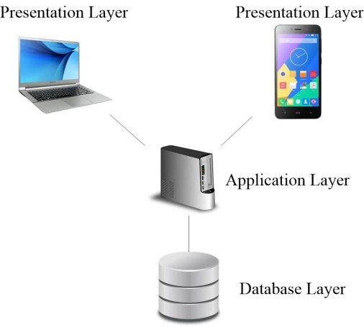

Figure : Three-tier architecture design for BuyMe

From the above figure, there are three layer in this architecture, which are presentation layer, application layer and database layer. Below is the description of each layer:

1. Presentation layer

This is the top-most layer which presenting the simple and useful user interface to system users and for collecting user inputs.

1. Application layer

This layer concerned with providing application specific functionality.

1. Database layer

This layer is used to store all the data input from user and can be retrieved easily.

For BuyMe system, the mobile application and web-based system is classified as the presentation layer which interacts with end user for getting the data input. The data input sends from mobile application to MySQL Database via XAMPP Server which is a web server that stores all the business rules at the server side. The connection between mobile application and web server is completed via HTTP. This server plays an important role in application layer. For the database layer, BuyMe store all the significant data in MySQL database.

**Class Diagram of BuyMe**

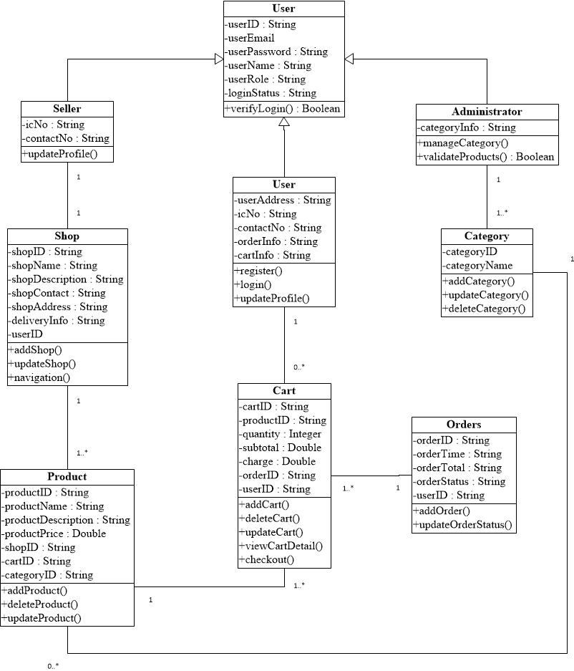

Figure : BuyMe Class Diagram

#### User Interface Design

##### Navigation Design

1. **Admin Webpage**

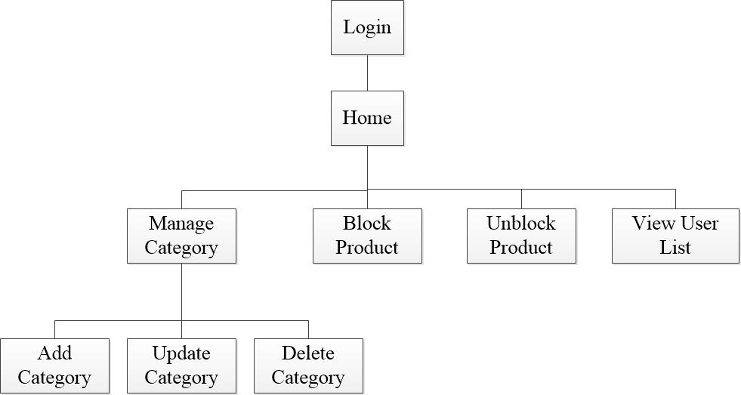

Figure : Navigation Design of Admin Webpage

1. **Seller Webpage**

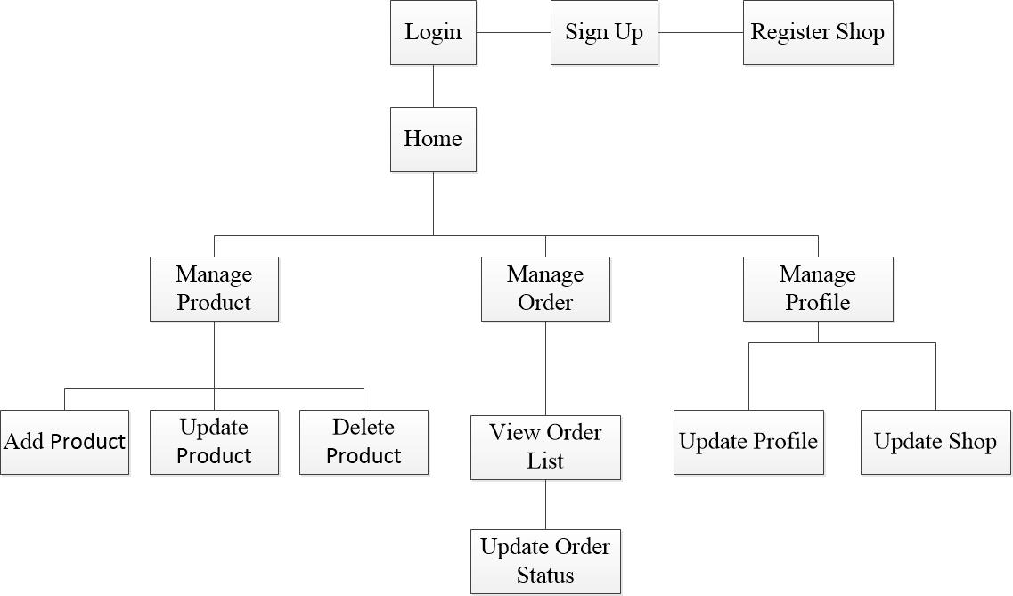

Figure : Navigation Design of Seller Webpage

1. **Mobile Application (User)**

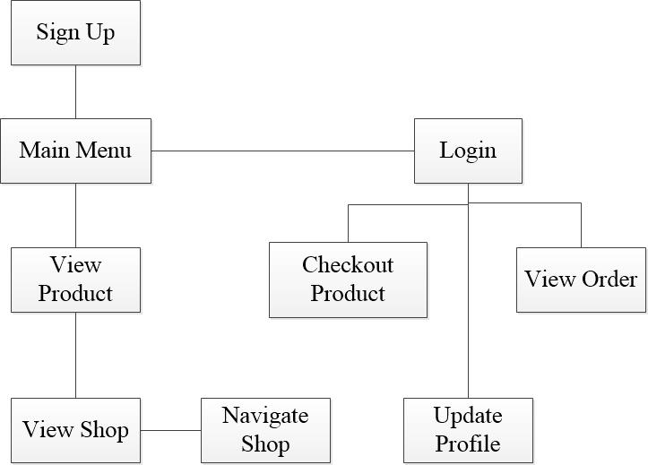

Figure : Navigation Design of Mobile User

##### Input and Output Design

1. **Admin Webpage**

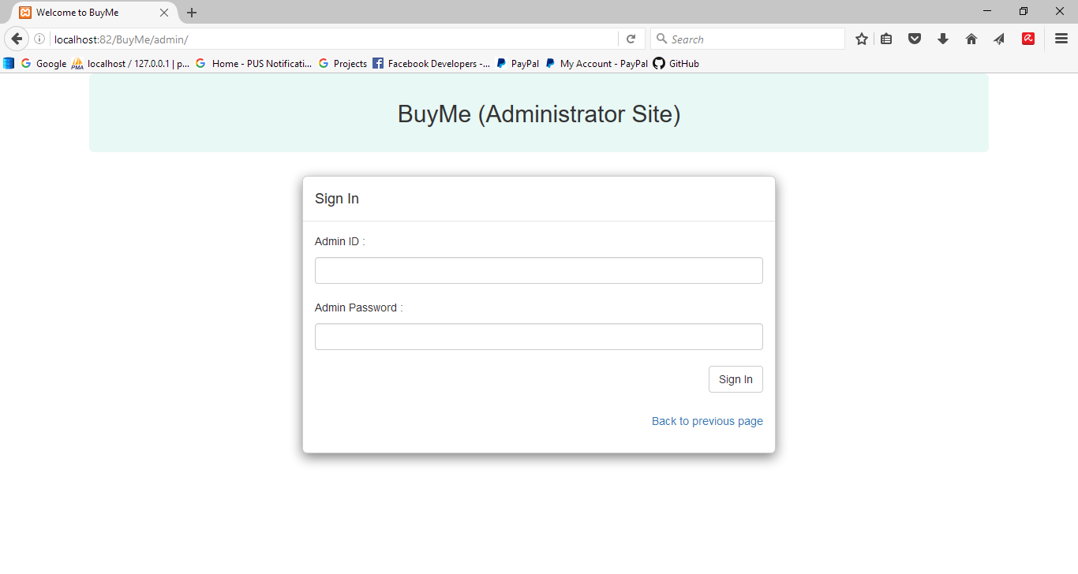

Figure : Admin Login Page

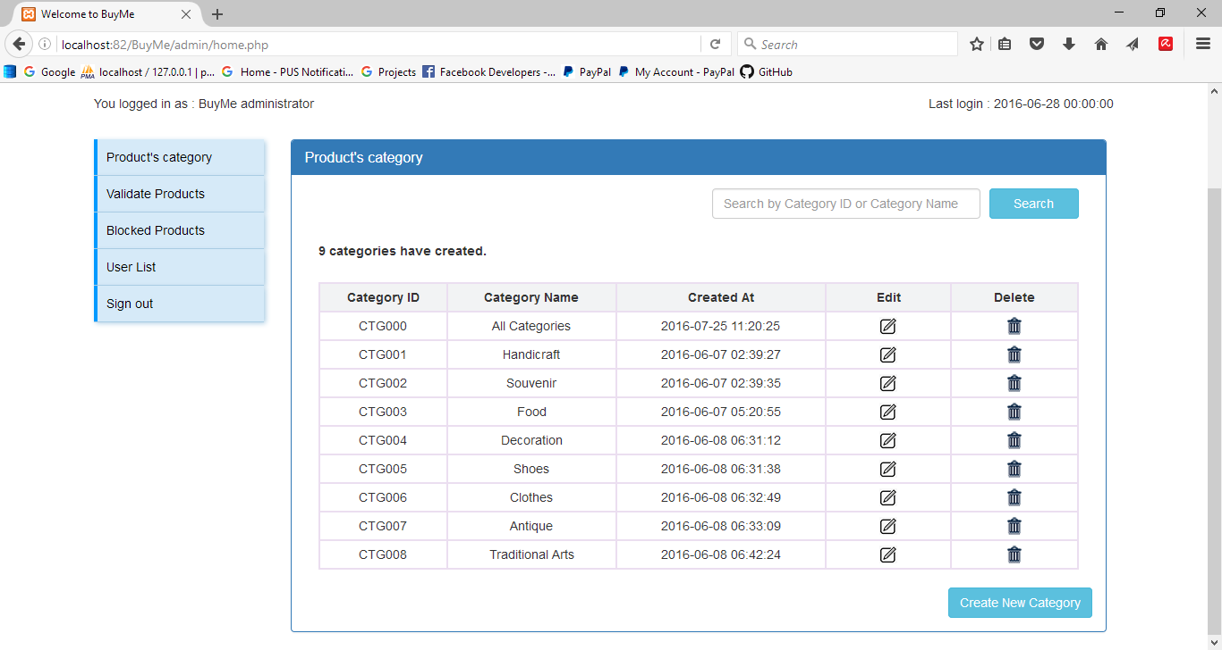

Figure : Admin Home Page (Product’s category)

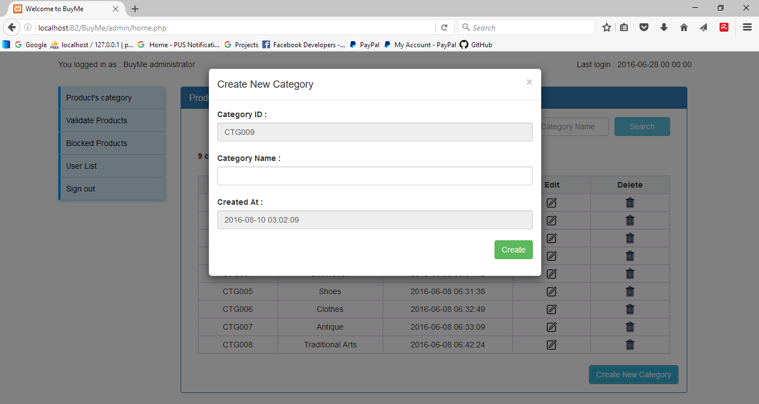

Figure : Admin Create New Category Window

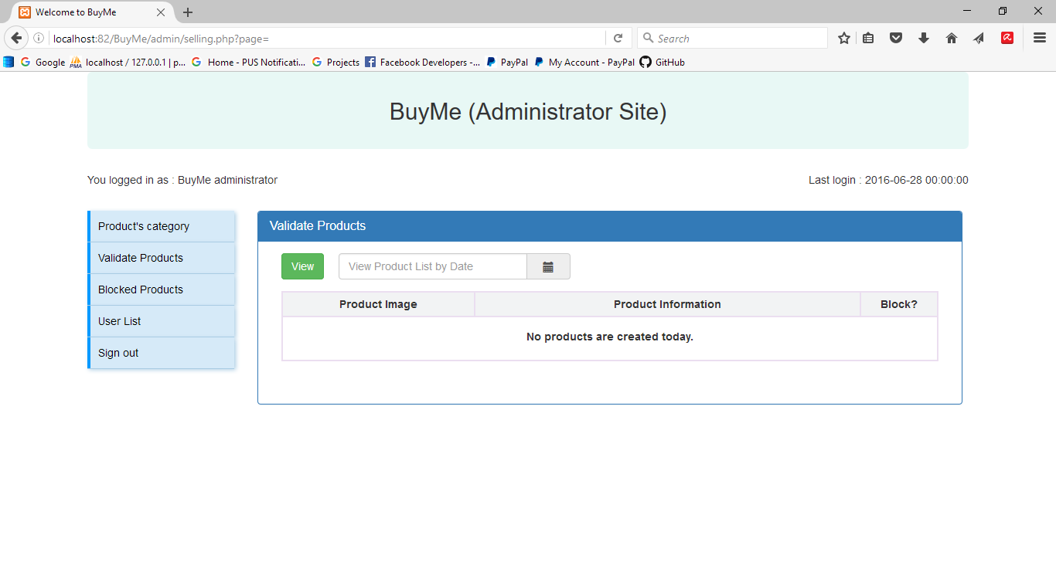

Figure : Admin Validate Products Page

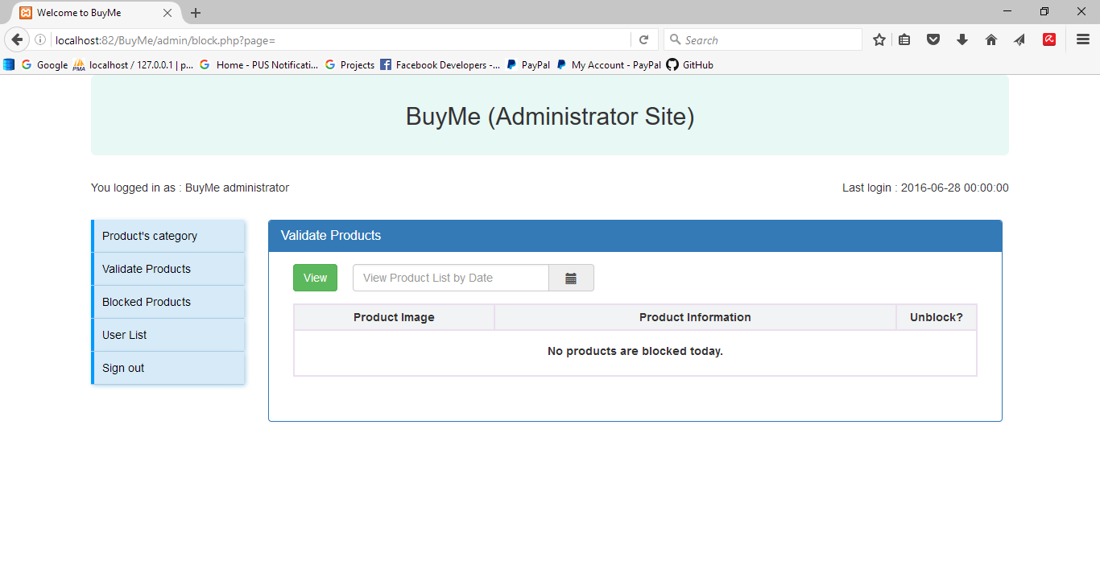

Figure : Admin Unblock Product Page

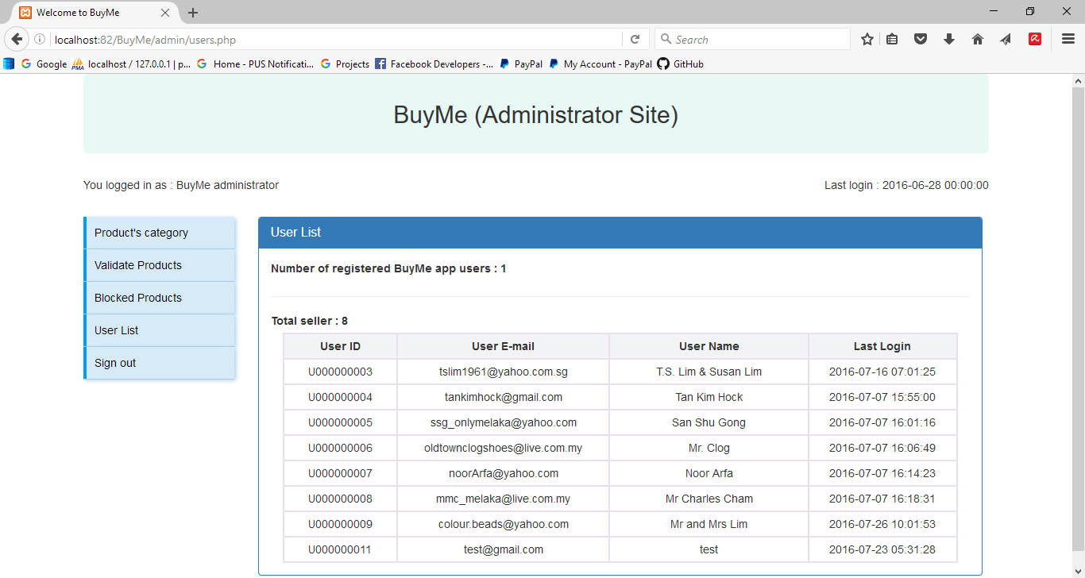

Figure : Admin View User List Page

1. **User Webpage**

**User Registration Page – Seller / User**

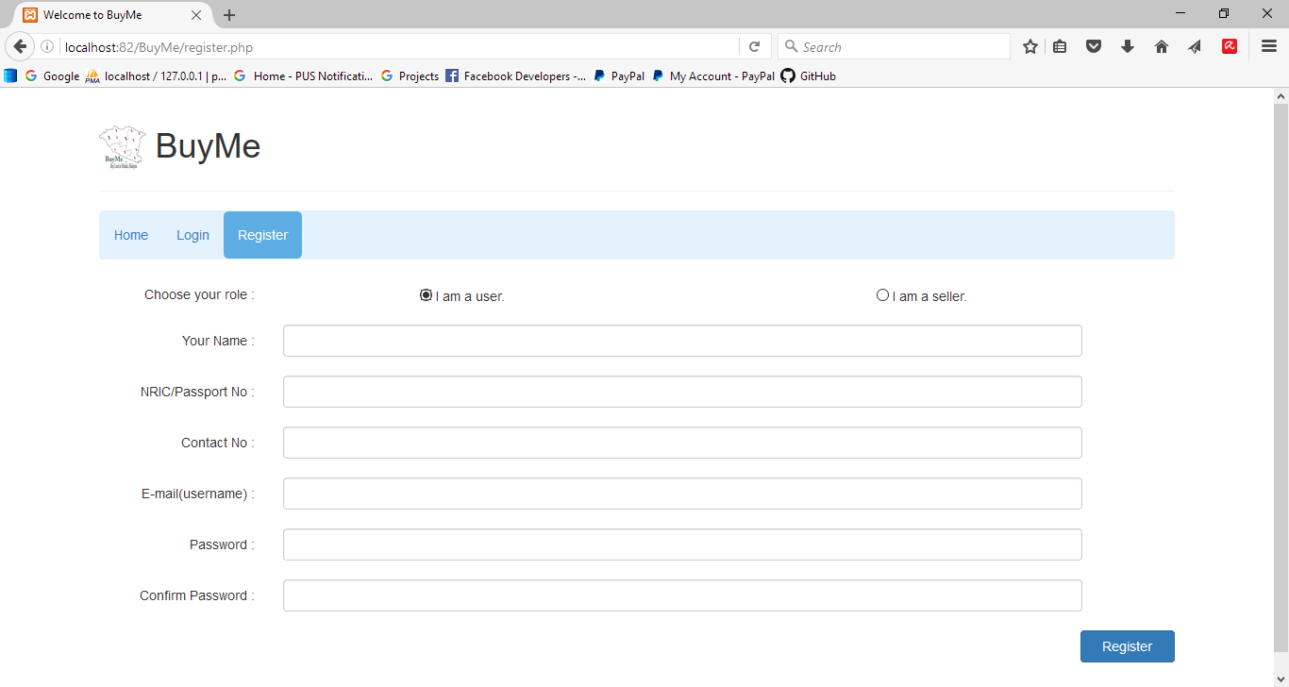

Figure : User Registration (Seller/User)

**User Login Page**

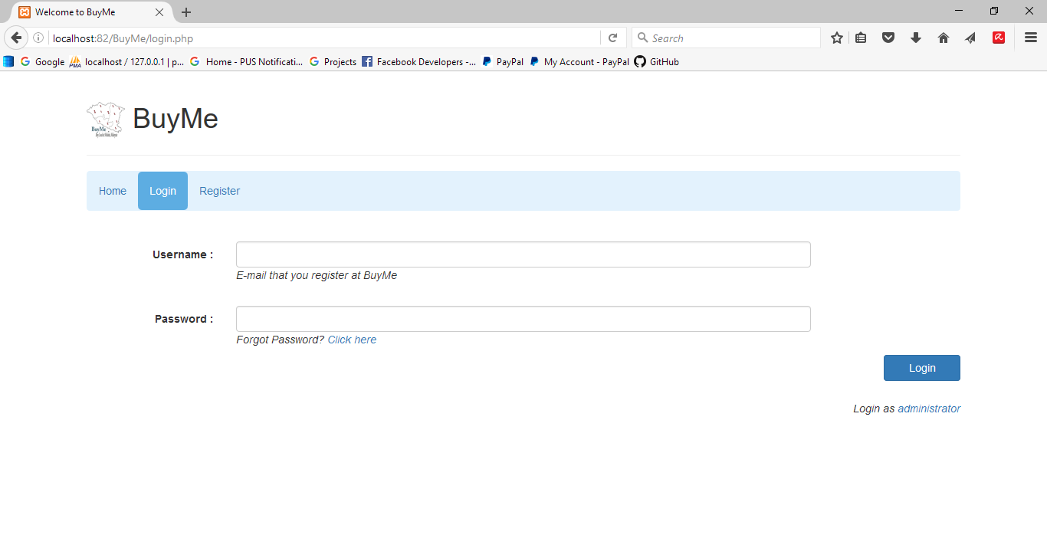

Figure : User Login Page

**Seller Home Page after Login**

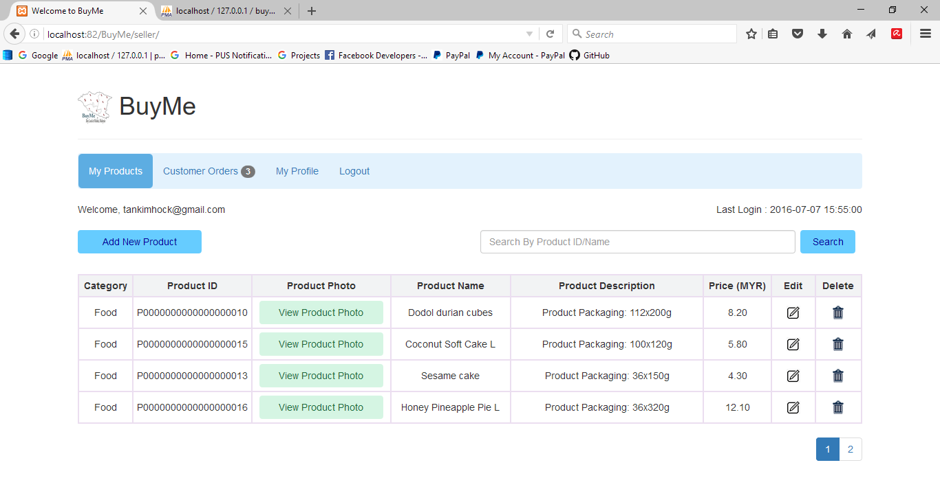

Figure : Seller Home Page (Manage Product)

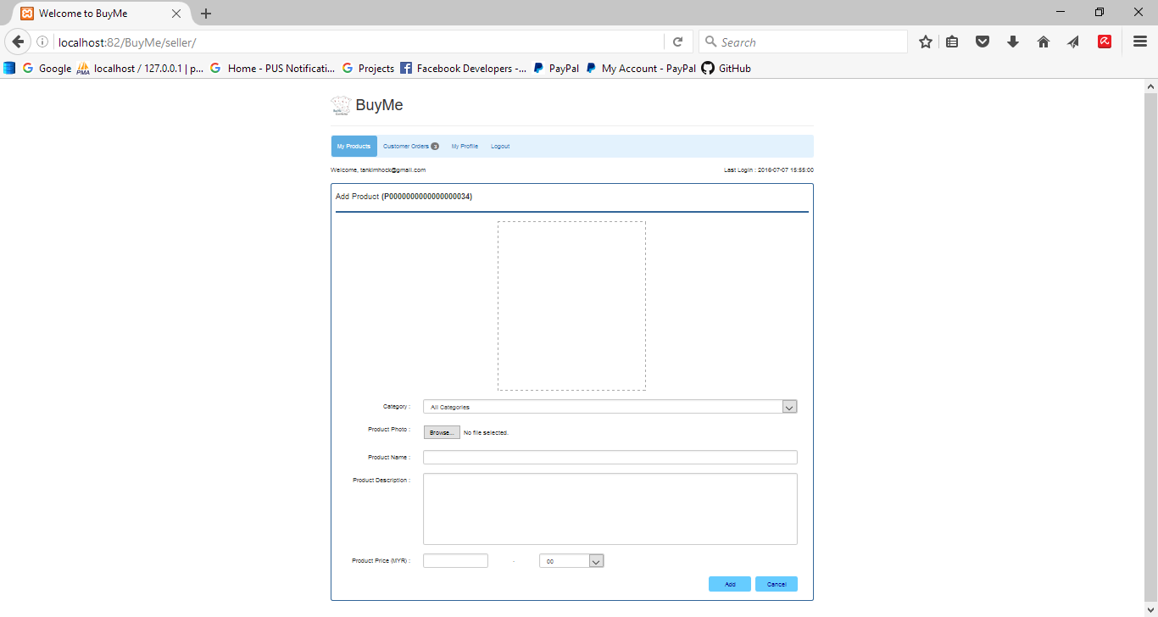

Figure : Add New Product Page

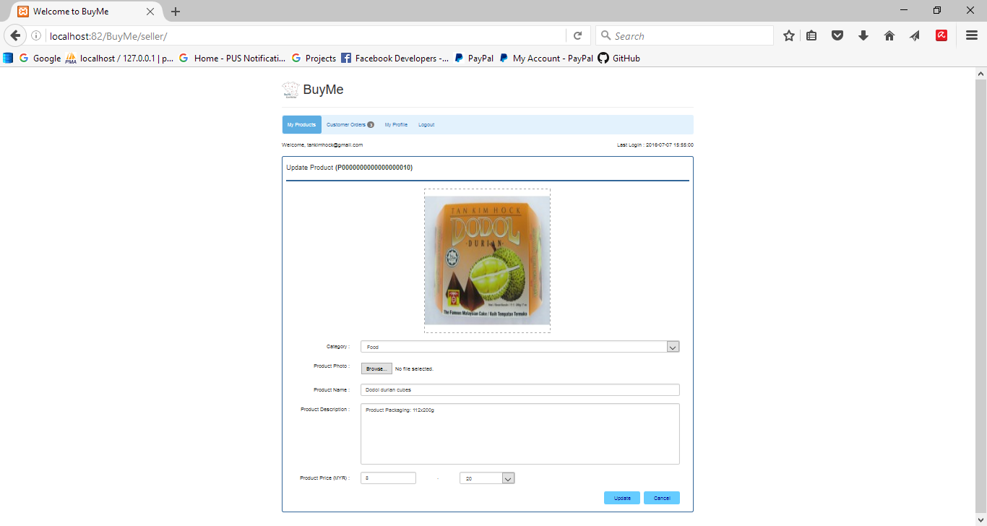

Figure : Edit Product Page

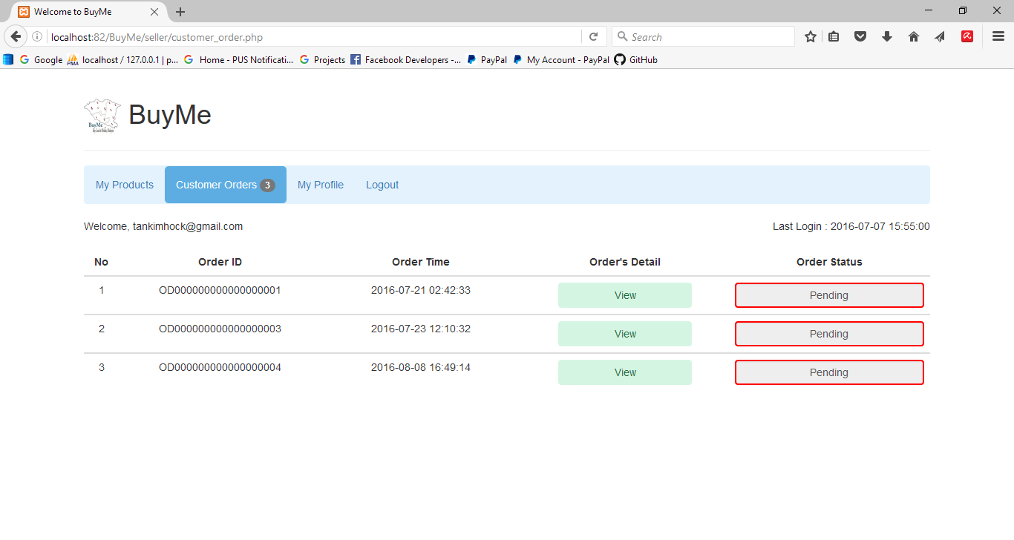

Figure : Customer Order Page

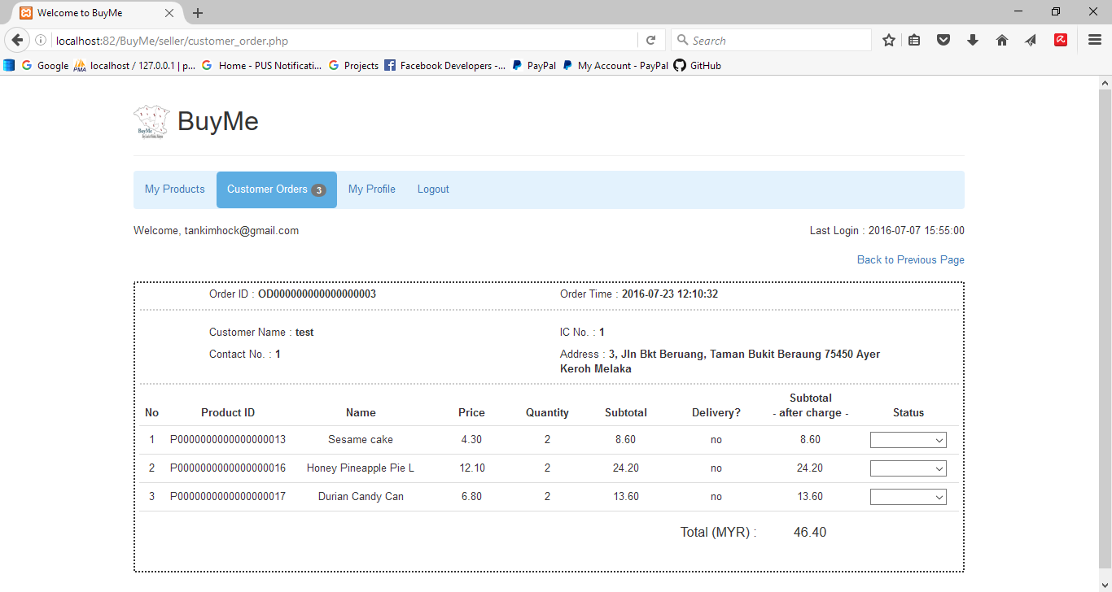

Figure : View Customer Order Detail Page

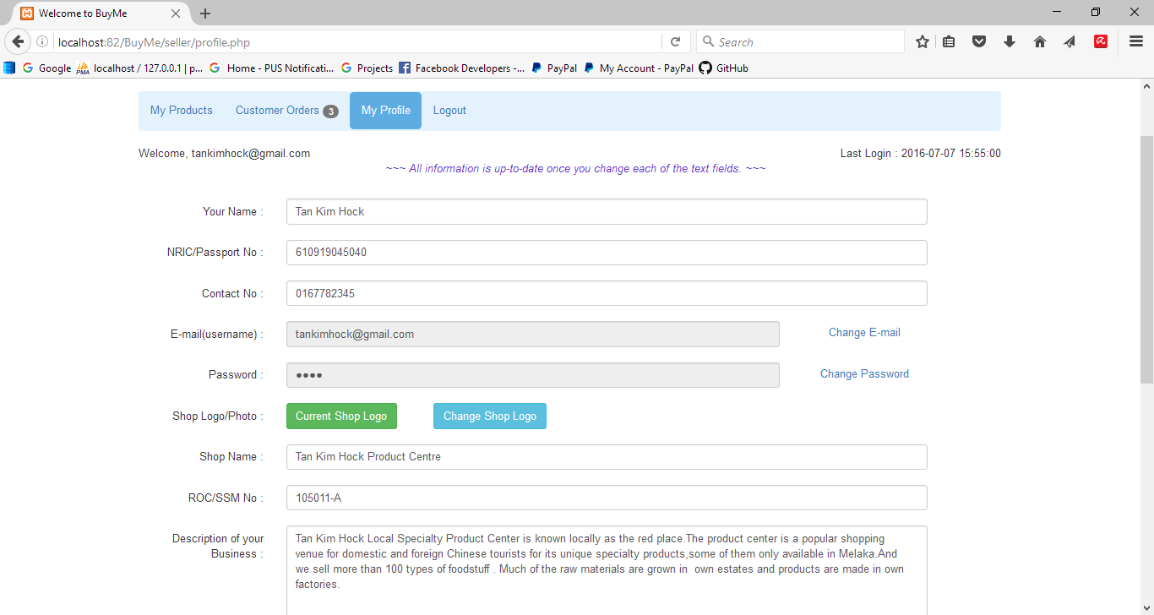

Figure : Seller Profile Page

**User Main Page (User Home Page after/before Login)**

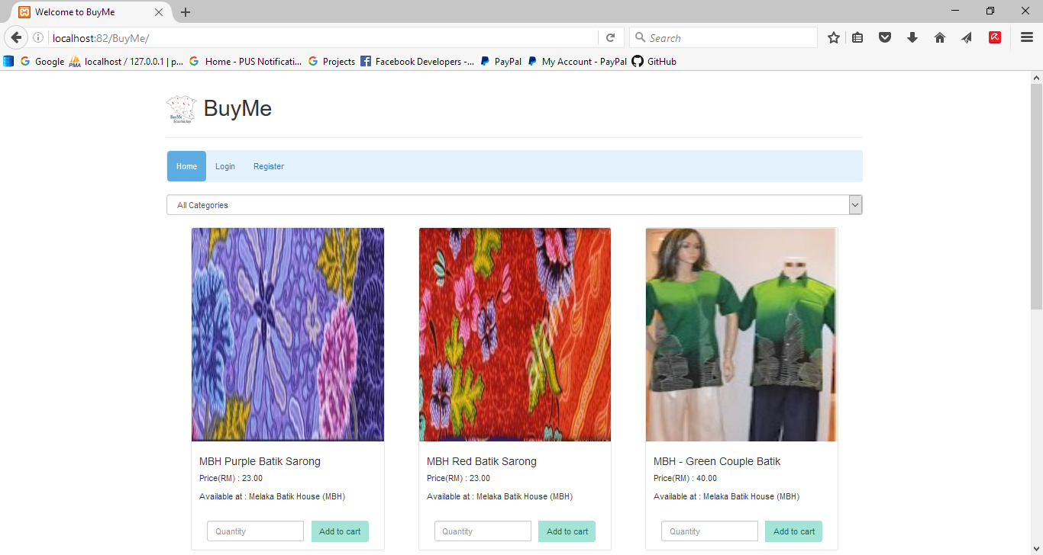

Figure : User Main Page

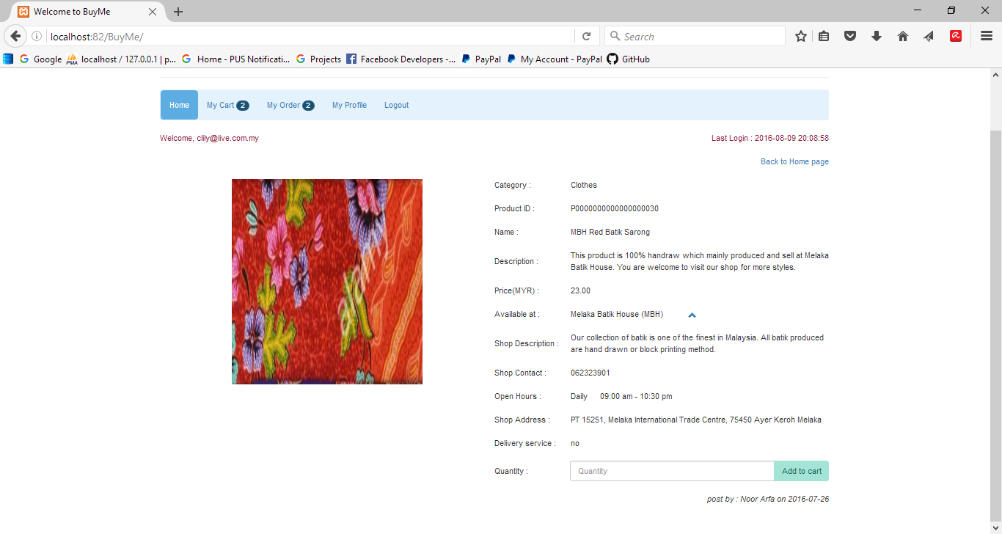

Figure : Product Detail Page

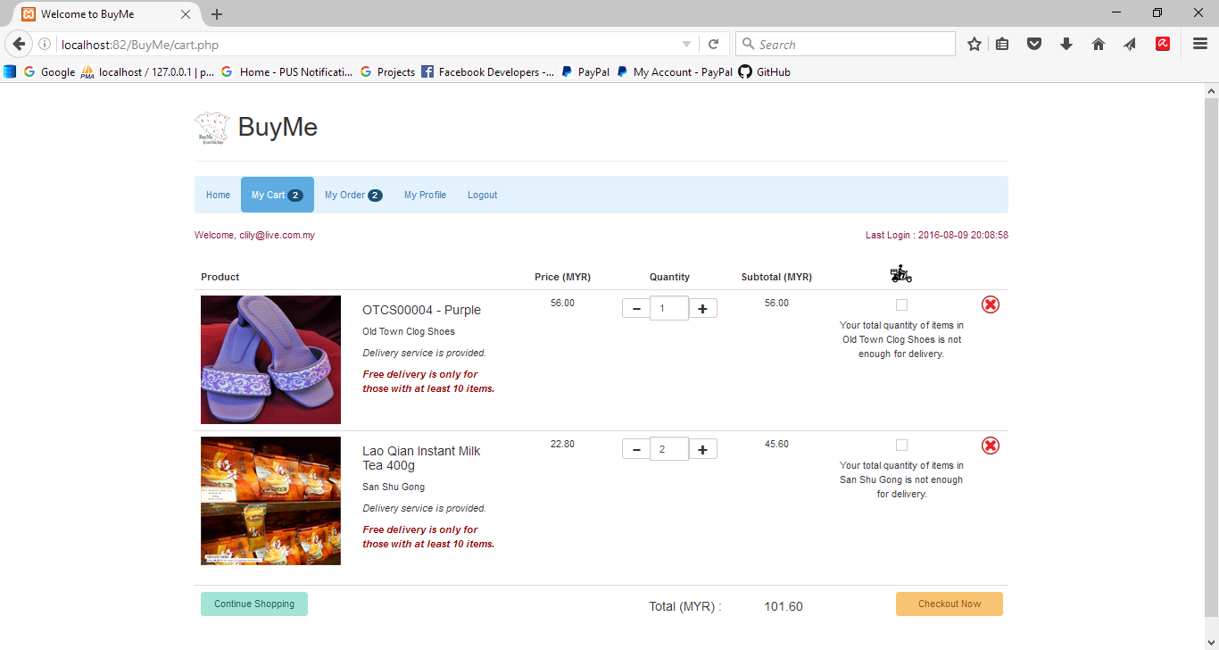

Figure : User Cart Page

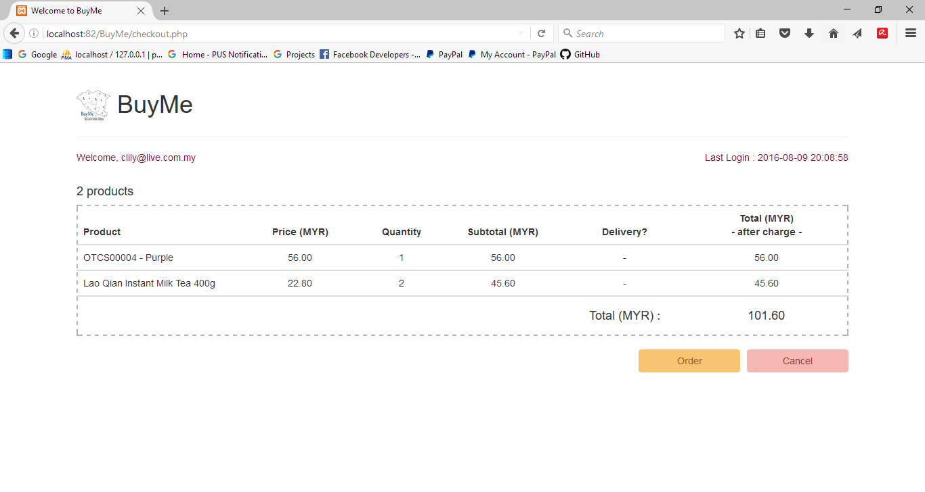

Figure : User Checkout Page

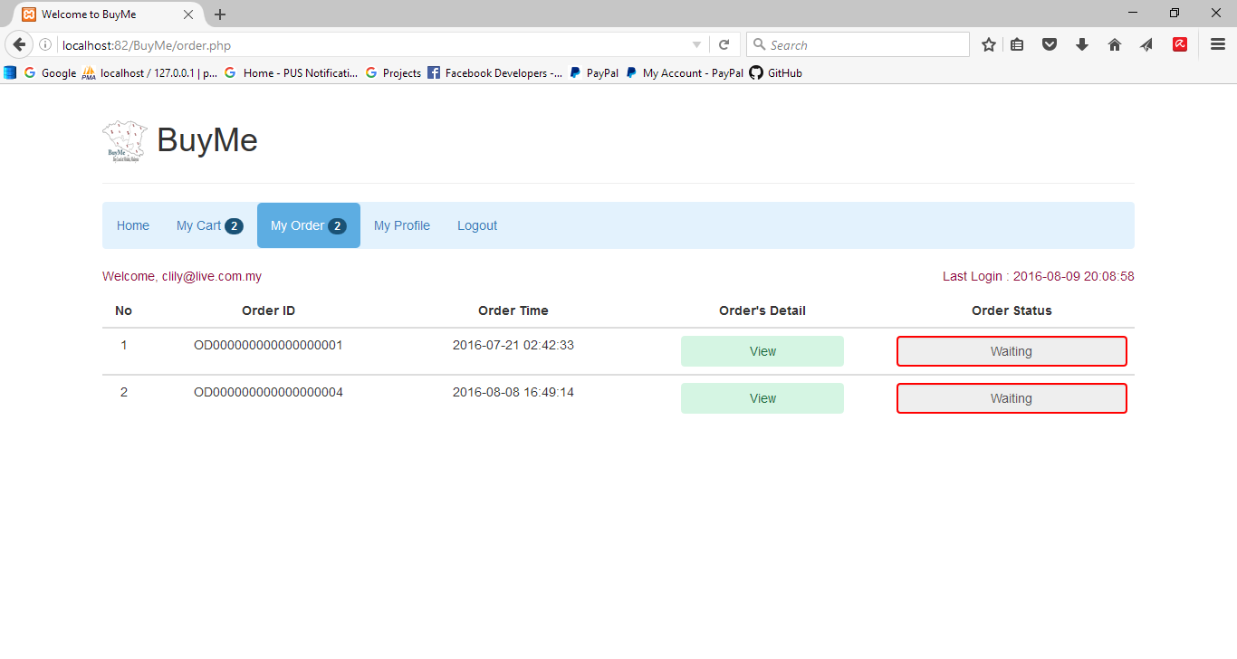

Figure : User Order List Page

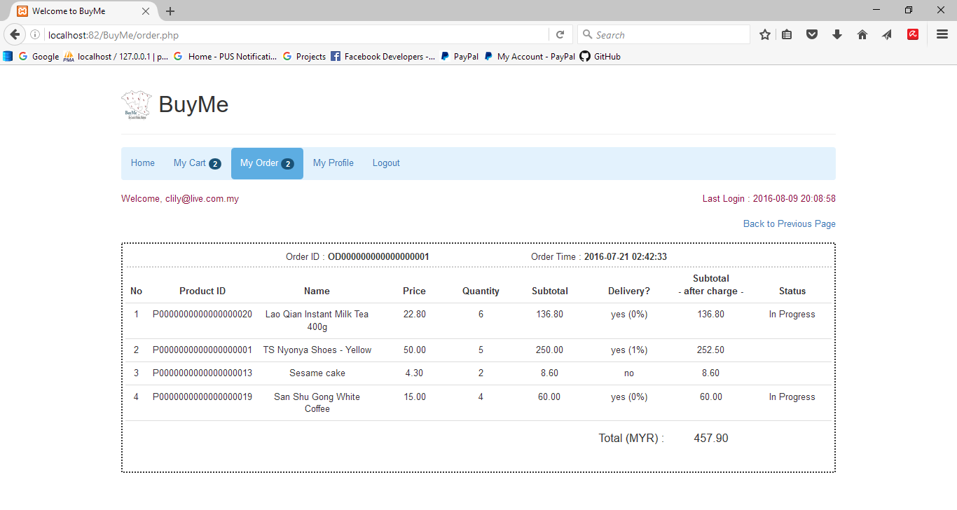

Figure : User Order Detail Page

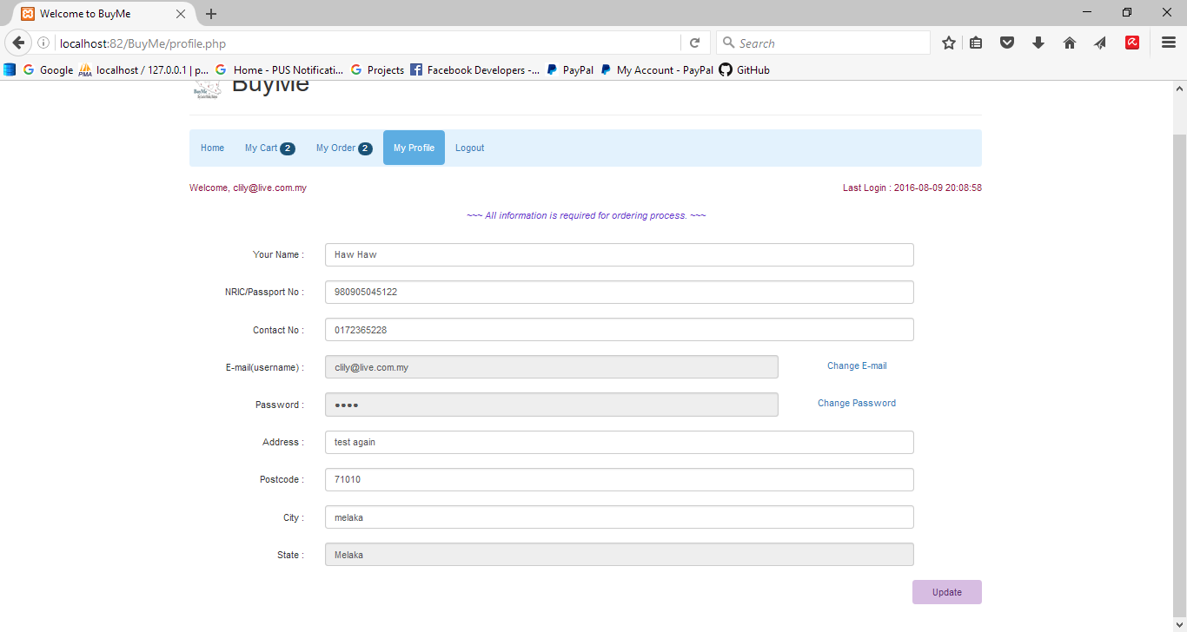

Figure : User Profile Page

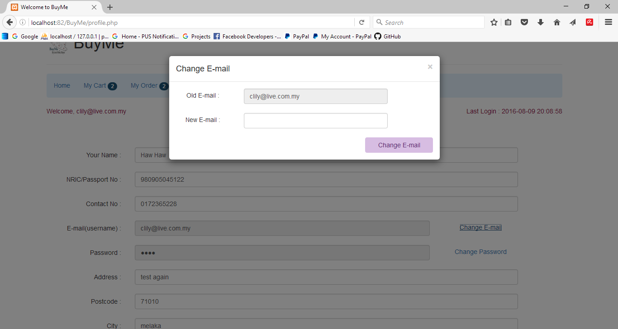

Figure : User Change Email Window

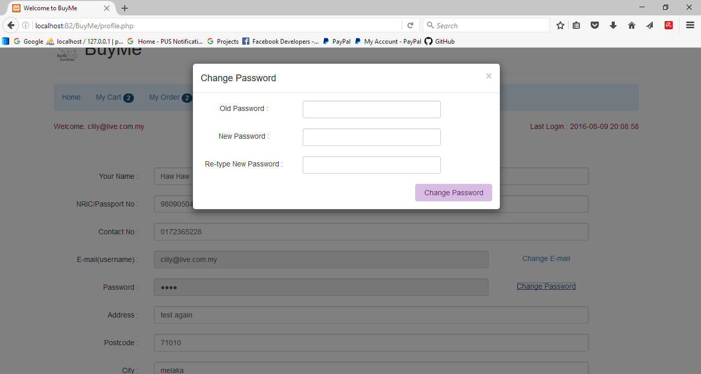

Figure : User Change Password Window

1. **BuyMe Mobile Application**

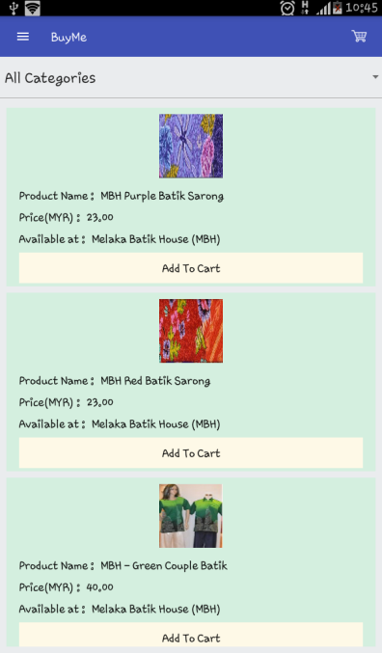

Figure : BuyMe Home Screen

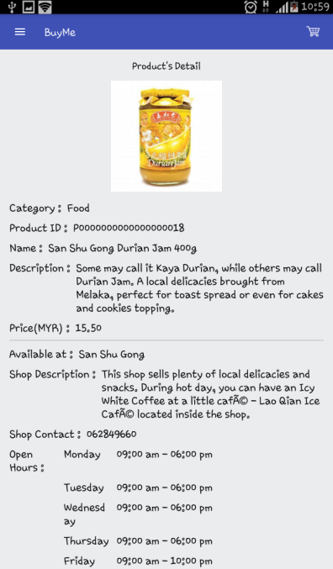 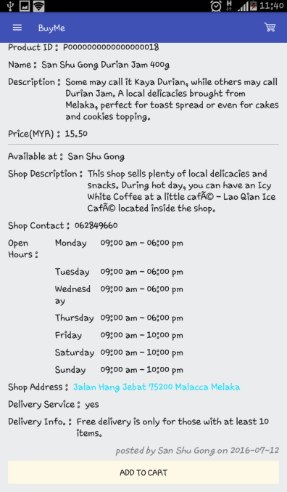

Figure : BuyMe Product Detail Screen

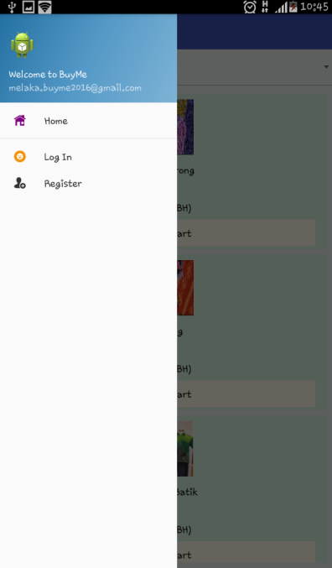

Figure : Menu Screen before User Login

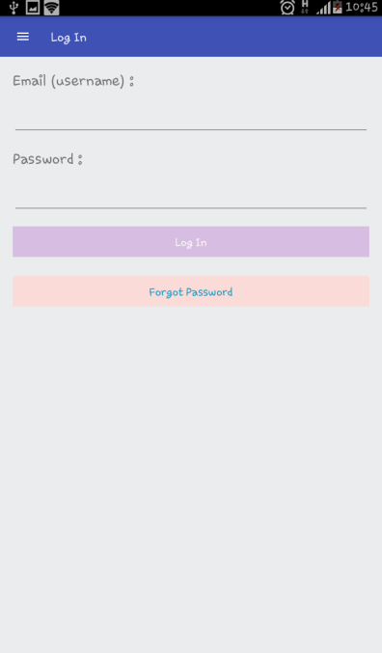

Figure : BuyMe Login Screen

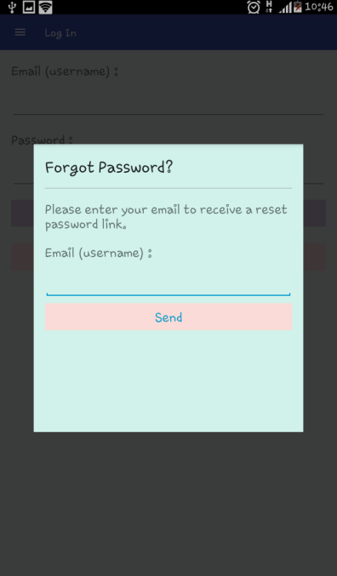

Figure : Forgot Password Screen

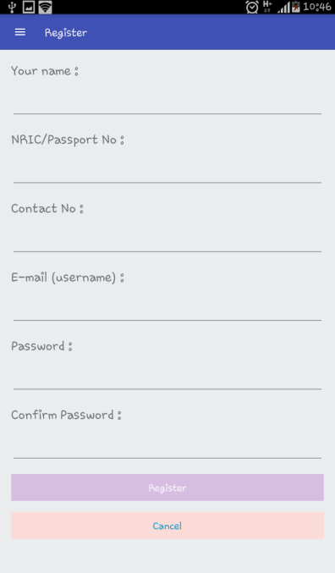

Figure : BuyMe User Sign Up Screen

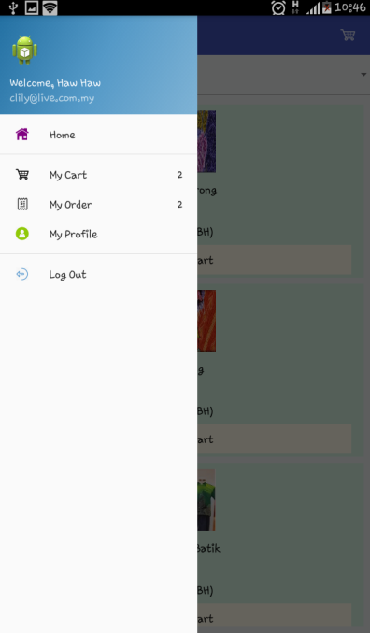

Figure : Menu Screen after User Login

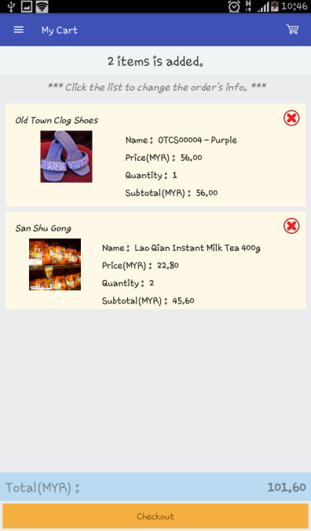

Figure : BuyMe Cart Screen

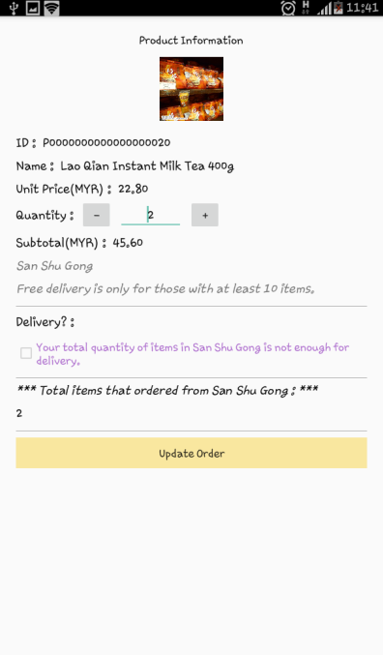

Figure : Cart Information Screen (for updating the quantity and choose delivery service)

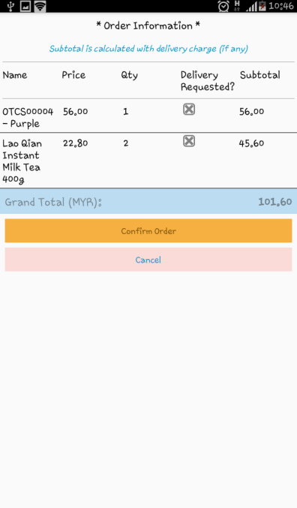

Figure : BuyMe Checkout Screen

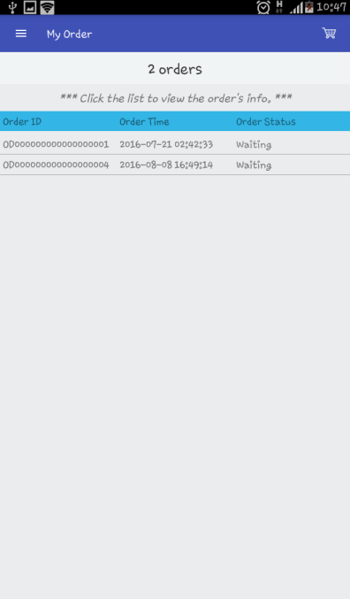

Figure : BuyMe Order Screen

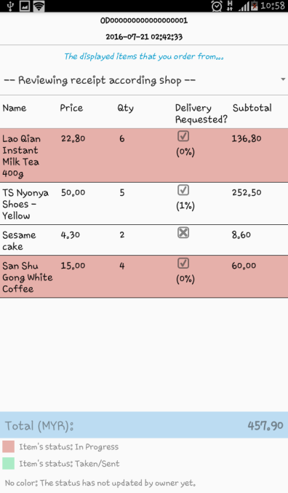

Figure : Order Information Screen

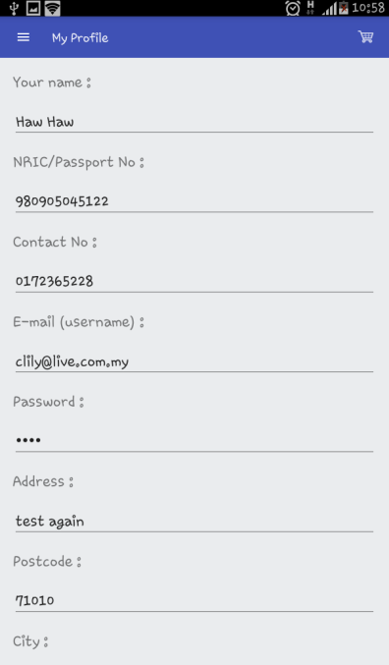

Figure : User Profile Screen

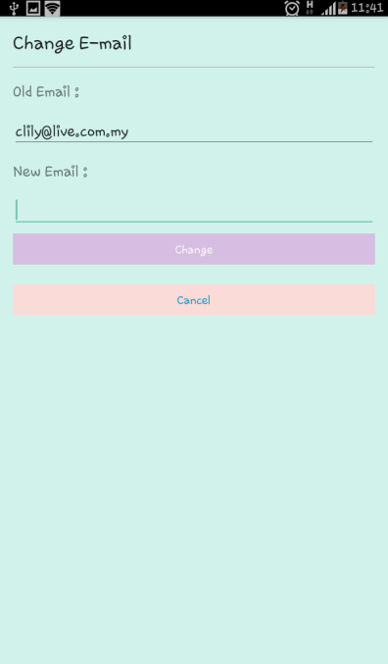 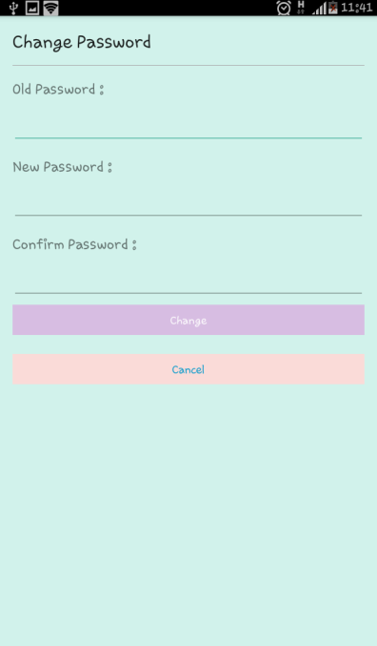

Figure : Change Email and Password Screen

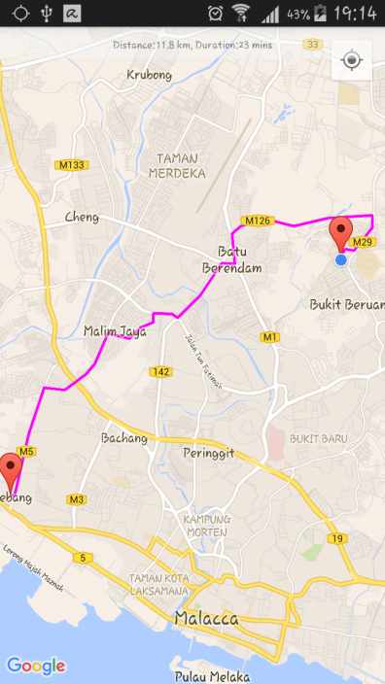

Figure : User View Shop Location Screen

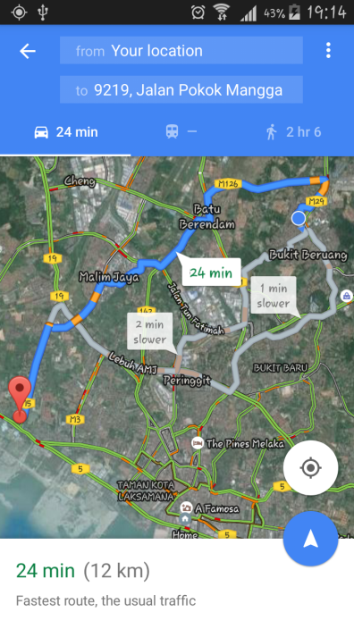

Figure : User Navigation Function Screen

#### Database Design

##### Conceptual and Logical Database Design

**BuyMe Entity Relationship Diagram (ERD)**

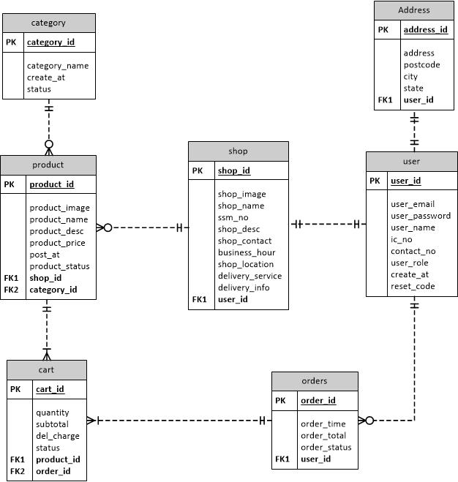

Figure : BuyMe ERD

**Business rules**

1. Each category has zero or more product.

Each product has only one category.

1. Each product has only one shop.

Each shop has zero or many product.

1. Each shop has only one user.

Each user has only one shop.

1. Each user has zero or many order.

Each order has only one user.

1. Each order has one or many cart.

Each cart is belonging to only one order.

1. Each product is belonging to only one cart.

Each cart has one or many product.

1. Each user has only one address.

Each address is belongs to a user.

**Data Dictionary**

|  |  |  |  |  |  |
| --- | --- | --- | --- | --- | --- |
| Field Name | Description | Type | Required | PK / FK | FK reference table |
| user_id | User ID | varchar(10) | Yes | PK | - |
| user_email | User email | varchar(260) | Yes | - | - |
| user_password | User password | varchar(15) | Yes | - | - |
| user_name | User name | varchar(150) | Yes | - | - |
| ic_no | User IC number | varchar(15) | Yes | - | - |
| contact_no | User contact number | varchar(11) | Yes | - | - |
| user_role | User role (admin/ seller/user) | varchar(15) | Yes | - | - |
| create_at | The date of account created / last logged in | datetime | Yes | - | - |
| reset_code | The password reset code | int(11) | No |  |  |

Table 10: Data dictionary of user entity

|  |  |  |  |  |  |
| --- | --- | --- | --- | --- | --- |
| Field Name | Description | Type | Required | PK / FK | FK reference table |
| address_id | Address ID | varchar(10) | Yes | PK | - |
| address | User address | varchar(100) | Yes | - | - |
| postcode | Place postcode | int(11) | Yes | - | - |
| city | City of state | varchar(50) | Yes | - | - |
| state | Malaysia State | varchar(50) | Yes | - | - |
| user_id | User ID | varchar(10) | Yes | FK | user |

Table : Data Dictionary of address entity

|  |  |  |  |  |  |
| --- | --- | --- | --- | --- | --- |
| Field Name | Description | Type | Required | PK / FK | FK reference table |
| category_id | Category ID | varchar(10) | Yes | PK | - |
| category_name | Name of category | varchar(100) | Yes | - | - |
| create_at | The date of category created | datetime | Yes | - | - |
| status | The status of category | varchar(10) | Yes | - | - |

Table : Data Dictionary of category entity

|  |  |  |  |  |  |
| --- | --- | --- | --- | --- | --- |
| Field Name | Description | Type | Required | PK / FK | FK reference table |
| shop_id | Shop ID | varchar(10) | Yes | PK | - |
| shop_image | Image of shop | longbob | Yes | - | - |
| shop_name | Name of shop | varchar(100) | Yes | - | - |
| ssm_no | SSM number of shop | varchar(20) | Yes | - | - |
| shop_desc | Description of shop | varchar(600) | Yes | - | - |
| shop_contact | Shop contact | varchar(10) | Yes | - | - |
| business_hour | Shop business hours | varchar  (1000) | Yes | - | - |
| shop_location | Shop location | varchar(100) | No | - | - |
| delivery_service | Delivery service | varchar(5) | Yes | - | - |
| delivery_info | Delivery information | varchar(100) | Yes | - | - |
| user_id | User ID | varchar(10) | Yes | FK | user |

Table 13: Data dictionary of shop entity

|  |  |  |  |  |  |
| --- | --- | --- | --- | --- | --- |
| Field Name | Description | Type | Required | PK / FK | FK reference table |
| product_id | Product ID | varchar(20) | Yes | PK | - |
| product_image | Image of product | longbob | Yes | - | - |
| product_name | Name of product | varchar(30) | Yes | - | - |
| product_desc | Description of product | varchar(600) | Yes | - | - |
| product_price | Price of product | varchar(10) | Yes | - | - |
| product_status | Status of product | varchar(10) | Yes | - | - |
| shop_id | Shop ID | varchar(10) | Yes | FK | shop |
| category_id | Category ID | varchar(10) | Yes | FK | category |
| post_at | The date of product created | date | Yes | - | - |

Table 14: Data dictionary of shop entity

|  |  |  |  |  |  |
| --- | --- | --- | --- | --- | --- |
| Field Name | Description | Type | Required | PK / FK | FK reference table |
| cart_id | Cart ID | varchar(20) | Yes | PK | - |
| product_id | Product ID | varchar(20) | Yes | FK | product |
| quantity | Quantity of product | int(11) | Yes | - | - |
| subtotal | Subtotal of product | Decimal(50,2) | Yes | - | - |
| del_charge | Delivery charge | varchar(50) | No | - | - |
| status | Product status | varchar(100) | No | - | - |
| order_id | Order ID | varchar(20) | No | FK | order |

Table 15: Data dictionary of cart entity

|  |  |  |  |  |  |
| --- | --- | --- | --- | --- | --- |
| Field Name | Description | Type | Required | PK / FK | FK reference table |
| order_id | Order ID | varchar(20) | Yes | PK | - |
| order_time | Time of order | datetime | Yes | - | - |
| order_total | Total of order | decimal  (50,2) | Yes | - | - |
| order_status | Status of order | varchar(40) | Yes | - | - |
| user_id | User ID | varchar(10) | Yes | FK | user |

Table 16: Data dictionary of order entity

### Detailed Design

#### Physical Database Design

**Create Table: user**

CREATE TABLE IF NOT EXISTS ‘user’ (

‘user_id’ varchar(10) NOT NULL,

‘user_email’ varchar(260) NOT NULL,

‘user_password’ varchar(15) NOT NULL,

‘user_name’ varchar(150) NOT NULL,

‘ic_no’ varchar(15) NOT NULL,

‘contact_no’ varchar(11) NOT NULL,

‘user_role’ varchar(15) NOT NULL,

‘create_at’ datetime NOT NULL,

‘reset_code’ int(11) DEFAULT NULL

PRIMARY KEY(‘user_id’))

**Create Table: address**

CREATE TABLE IF NOT EXISTS ‘address’ (

‘address_id’ varchar(10) NOT NULL,

‘address’ varchar(100) NOT NULL,

‘postcode’ int(11) NOT NULL,

‘city’ varchar(50) NOT NULL,

‘state’ varchar(50) NOT NULL,

‘user_id’ varchar(10) NOT NULL

PRIMARY KEY(‘cart_id’),

FOREIGN KEY(‘user_id’) REFERENCES user(‘user_id’))

**Create Table: category**

CREATE TABLE IF NOT EXISTS ‘category’ (

‘category_id’ varchar(10) NOT NULL DEFAULT ,

‘category_name’ varchar(100) NOT NULL,

‘create_at’ datetime NOT NULL DEFAULT CURRENT_TIMESTAMP,

‘status’ varchar(10) NOT NULL

PRIMARY KEY(‘category_id’))

**Create Table: product**

CREATE TABLE IF NOT EXISTS ‘product’ (

‘product_id’ varchar(20) NOT NULL,

‘product_image’ longblob NOT NULL,

‘product_name’ varchar(30) NOT NULL,

‘product_desc’ varchar(600) NOT NULL,

‘product_price’ varchar(10) NOT NULL,

‘post_at’ date NOT NULL,

‘category_id’ varchar(10) NOT NULL,

‘shop_id’ varchar(10) NOT NULL,

‘product_status’ varchar(10) NOT NULL

PRIMARY KEY(‘product_id’),

FOREIGN KEY(‘category_id’) REFERENCES category(‘category_id’),

FOREIGN KEY(‘shop_id’) REFERENCES shop(‘shop_id’))

**Create Table: cart**

CREATE TABLE IF NOT EXISTS ‘cart’ (

‘cart_id’ varchar(20) NOT NULL,

‘product_id’ varchar(20) NOT NULL,

‘quantity’ int(11) NOT NULL,

‘subtotal’ decimal(50,2) NOT NULL,

‘del_charge’ varchar(50) NOT NULL,

‘status’ varchar(100) DEFAULT NULL,

‘order_id’ varchar(20) DEFAULT NULL

PRIMARY KEY(‘cart_id’),

FOREIGN KEY(‘product_id’) REFERENCES product(‘product_id’),

FOREIGN KEY(‘order_id’) REFERENECES order(‘order_id’))

**Create Table: shop**

CREATE TABLE IF NOT EXISTS ‘shop’ (

‘shop_id’ varchar(10) NOT NULL,

‘shop_image’ longblob NOT NULL,

‘shop_name’ varchar(100) NOT NULL,

‘ssm_no’ varchar(20) NOT NULL,

‘shop_desc’ varchar(600) NOT NULL,

‘shop_contact’ varchar(10) NOT NULL,

‘business_hour’ varchar(1000) NOT NULL,

‘shop_location’ varchar(100) DEFAULT NULL,

‘delivery_service’ varchar(5) NOT NULL,

‘delivery_info’ varchar(100) NOT NULL,

‘user_id’ varchar(10) NOT NULL

PRIMARY KEY(‘shop_id’),

FOREIGN KEY(‘user_id’) REFERENCES user(‘user_id’))

**Create Table: orders**

CREATE TABLE IF NOT EXISTS ‘orders’ (

‘order_id’ varchar(10) NOT NULL,

‘order_time’ datetime NOT NULL,

‘order_total’ decimal(50,2) NOT NULL,

‘order_status’ varchar(40) NOT NULL,

‘user_id’ varchar(10) NOT NULL

PRIMARY KEY(`orderID`)

FOREIGN KEY(`userID `) REFERENECES user(userID))

### Conclusion of Chapter IV

For overall, this chapter provides the details of database design and user interface about this proposed system. The system architecture makes the implementation phase become easier as it gives clear information about the usage of data and defines the process of this system. The next chapter will be discussed on the implementation phase after the design has been complete.

# CHAPTER V

## IMPLEMENTATION

### Introduction

This chapter describes the implementation process of the system that requires deploying into operational system. The beginning of this chapter will be discussed on the software development environment that need to setup for developing an Android mobile application and web-based system, and also the tools for the database server connection. Next, the details of the software project configuration management and the implementation status also included in this chapter.

### Software Development Environment Setup

The minimum system requirements of the hardware configuration are tabulated in the following table.

|  |  |  |
| --- | --- | --- |
| Item | Requirement | Minimum configuration |
| ASUS A43S series laptop | Processor  Memory  RAM  Operating System | Intel(R) Core ™ i3-2310M 2.10Ghz  2GB  8GB  64-bit Windows 10 Education Operating System |
| Samsung GT-N7100 | Display size  Memory(external)  Memory(internal)  Android Version  GPS | 5.5-inch  8 GB  16 GB  4.4.2 (KitKat)  Yes |

Table : Hardware Configuration

The software configurations that are used to set up an Android development environment and web development environment are as below:

1. Android Studio 2.1.2

Android Studio is the official integrated development environment (IDE) for Android platform development. It is written in Java programming language based. It is free and available to install under Apache License 2.0. This software is suitable and easy to use by developer because it comprises all the required tools without installed other plugin like SDK manually.

1. Adobe Dreamweaver CS5

Adobe DreamWeaver CS6 will use to develop the PUS web based system. The details of this software system are described in the following paragraphs. Adobe DreamWeaver is a closed-source web development tool that is originally created by Macromedia. The provided tools by the Dreamweaver contains solution and subsequent version that more compliant with W3C standards. Adobe Dreamweaver CS5 supports scripting languages and frameworks including ASP,Scriplet and PHP. It is a web design and development application that provides visual with standard features as well as more sophisticated features such as real-time syntax checking and code introspection for generating code hints to assist the user to write codes and reduced syntax error and misspelling. Adobe Dreamweaver also facilitates with rapid layout design and code generation as it allow users to quickly create and manipulate the layout.

1. XAMPP Server v3.2.1

XAMPP Server version 3.2.1 is used to store the PUS database in local host. The details of this software system are described in the following paragraphs. XAMPP Server version 3.2.1 used is automatically installed with Apache, PHP, MySQL database, phpMyAdmin and other packages. XAMPP is a free and open source cross-platform web server solution stack package developed by Apache Friends, consisting mainly of the Apache HTTP Server, MySQL database, and interpreters for scripts written in the PHP and Perl programming languages. Some package provided like phpMyAdmin in XAMPP is required to build this project database, which the database is stored in localhost in order to avoid the database lose in unexpected conditions.

### Software Configuration Management

#### Configuration Environment Setup

BuyMe connects to MySQL as its Database Management System (DBMS). Therefore, XAMPP need to install in laptop for accessing the online localhost database. BuyMe application is only runs and shows all the information under internet connection. MySQL database is run on localhost, hence, software named wifi hotspot need to install and open for connecting with the Android mobile device, in order to have the same IP address with localhost personal computer. Wifi hotspot is shared internet software that installed on computer. It converts the network that the computer connects to wifi which can be used by everyone with the correct password. Android mobile device need to change the IP address manually for every wifi connection.

#### Version Control Procedure

This section describes the procedure to control BuyMe sources code management. There are several steps in version control procedure. It records the steps from the beginning of the source code implementation development. The initial version is a more crucial stage as it is the started step to develop the functionality of the system. Table below present the proposed version of BuyMe.

|  |  |
| --- | --- |
| Version | Description |
| BuyMe v1 | Initial version (for the purpose of user acceptance test). This version only can view the system navigation flow and interface design. No function is added to this version. |
| BuyMe v2 | Second version (webpage development). Adobe Dreamweaver CS5 and XAMPP server should be installed in the laptop. All the source codes for webpages are completed. |
| BuyMe v3 | Third version (mobile application development). Android Studio should be installed in laptop. All the source codes for android device are completed. |
| BuyMe v4 | Full version. The system for both webpage and android is uploaded into the online database and all tests are done including error handling. |

Table : Proposed version for BuyMe

### Implementation Status

The table below shows the implementation status for each modules of this proposed system:

|  |  |  |
| --- | --- | --- |
| Module/Function | Description | Duration to complete (week) |
| Interface Design | Develop user interface of the system | Two |
| Database Design | Develop database and its relationship | One |
| Admin Module | Develop admin webpage include the function such as manage category, block and unblock product, and view user list. | Two |
| Seller Module | Develop seller webpage include the function such as manage shop, manage product, and view order list, as well as the function of tracking current location in Google map. | Three |
| BuyMe user mobile application | Develop all the basic functions such as search, view, login, register and send order to seller website. | Three |

Table : Implementation status for each module

### Conclusion of Chapter V

The summarization of this chapter is the project must have a proper software development environment setup to avoid the unexpected condition occur. Other than that, developer able to manage the changes on the source code via reliable version control based on the software configuration management. The next chapter will focused on the system testing, where it includes the test plan, test strategy, test design, as well as test results and analysis.

# CHAPTER VI

## TESTING

### Introduction

Software testing is an essential technique to ensure the quality of a software product. It is the process of analyzing a software item to detect the difference between existing and required conditions and to evaluate the features of the software item.

This section will discuss about the detail of system testing. The detail includes test plan, test strategy, test design as well as the test result and analysis. The main activity will involve in testing phase are the targeted user will be the tester for this system to test the part that they involved in this system. The testing is divided into six parts, which are unit testing, integration testing, functional testing, system testing, acceptance testing and regression testing. The strategy that will adopt for testing is white-box and black-box testing and top-down testing. *(Please refer section 6.3 for the definition of testing strategy and the information of test requirements.)*

### Test Plan

#### Test Organization

Test organization is a team who will undergo the testing phase. There are two personnel will involve in testing part, who are the selected users who suitable to use this system, the software developer (Cheok Li Li) and the project’s supervisor (Dr. Massila).

The selected users have the responsible to test the function of the module they involve. For seller, the modules involved are the management of the product (add, update and delete), check the order whether the ordered item sent to their account is correct, make sure the function of order status updated well and the modules of viewing the created item is match with their shop in BuyMe user home page.

For administrator, the modules involved are management of category (add, delete, update), make sure products’ validation (which includes block and unblock function) are function well and the viewing of the number of registered user in BuyMe.

For user, the modules involved are the information of product and shop is displayed in an ordered and tidy way, the modules of add to cart, the checkout module, make sure the product they add is the right in cart page, ensure the calculation in cart and order page are match and correct.

While software developer needs to check and test the entire system. The software developer has the responsible to record test error and result when the tester found the error or the system fail to function in the specific modules. The project’s supervisor has the responsible to suggest the correction on some modules.

#### Test Environment

The testing will be carried out in the place that surrounded by network (local internet / Wi-Fi / mobile data) as the system needs to connect with internet to access the data in online based. The location can be anywhere that suitable and comfortable for the tester and software developer to test the software product.

The hardware involved is computer, laptop and an Android mobile phone with KitKat 4.4.2. The preparation for testing the product include the setting of same IP address, both the computer and mobile device have to connect to the same network because the system acts as a testing prototype only and has not yet deploy with a real server.

#### Test Schedule

There are six task required in testing phase. The following table describes each task and the duration to complete the task.

|  |  |  |  |  |
| --- | --- | --- | --- | --- |
| Testing Task | Description | Duration (days) | Start Date | End Date |
| Unit Testing | Testing on smallest testable parts of this system. | 13 | 27/06/2016 | 09/07/2016 |
| Integration Testing | Testing on several modules immediately. | 8 | 10/07/2016 | 17/07/2016 |
| Functional Testing | This testing is based on the test cases that describe in section 6.4. | 6 | 18/07/2016 | 23/07/2016 |
| System Testing | Testing on the complete integrated system. | 7 | 24/07/2016 | 30/07/2016 |
| Acceptance Testing | Testing based on the specification requirements that agreed in the analysis phase. | 10 | 31/07/2016 | 09/08/2016 |
| Regression Testing | Testing on the modules that has been updated or changed to ensure that the system is still performing correctly. | 5 | 10/08/2016 | 15/08/2016 |

Table : Test schedule

### Test Strategy

Based on the test schedule in section 6.2, this system will undergo six types of testing. Each testing level has it testing strategy, whether it is suitable for using white-box or black box testing.

White-box testing is a testing that takes into account the internal behavior of a system or component. This testing is also called structural testing and glass-box testing. For this project, software developer will involve in this testing as this testing require the one who has the knowledge of programming. Unit testing, integration testing and regression testing will use this strategy to test the system.

Black-box testing is a testing that ignores the internal behavior of a system or component and focuses solely on the outputs, generates in response to selected inputs and execution condition. It is also called functional testing. The user who has no programming knowledge is selected to test the system. They only need to input the correct data that suit to this system and examine the output response from the system. They have to make sure the result is what they has been requested. Unit testing, functional testing, system testing and acceptance testing will this strategy to test the system.

Other than that, top-down testing is used in the integration level. The software developer is responsible in this testing. The highest level of the system (user interface) is tested first and followed by the internal mechanism of the software system. The critical part in the software system is the accurate data that passed between the front-end and the value being provided by the developed system.

#### Classes of tests

There are two classes of tests which are used in this project as mentioned in section 6.3, which are Black-box testing and White-box testing. Both testing description is listed in the table below.

**White-box Testing Class**

|  |  |
| --- | --- |
| White-box Testing (Non-Functional) | Description |
| Performance | The data in BuyMe website and mobile application need to display within 5 seconds after click/select button. |
| Internet connectivity | BuyMe mobile application can be access only in the connection of internet. |
| Data integrity | All the data displayed in BuyMe website and mobile application is in accordance with the data in the BuyMe database. |

Table : Classes of test (White-box)

**Black-box Testing Class**

|  |  |
| --- | --- |
| Black-box Testing (Functional) | Description |
| Interface | The interface of BuyMe website is responsive to all the browser such as Internet Explorer (IE) 9 and above, latest Google Chrome version and the latest Mozilla Firefox version. While for BuyMe application, the interface is with the version of Android KitKat and above. All the input fields are function. |
| Regression | Regression testing is the most important part in testing. All the related function should be tested after the internal mechanism has been changed to ensure that there is no running error and not affected the system modules. |
| Output of correctness | The input test data is required to receive the output data. The output test data is correct and accurate with what is expected, such as the input data for product Keris is output with it description and the owner detail. |

Table : Classes of test (black-box)

### Test Design

#### Test Description

This section will describe the test case identification, test cases and the expected result. The test case is based on each of the modules in this system.

**Test Cases for Admin**

|  |  |  |  |
| --- | --- | --- | --- |
| Module | Test Case ID | Description | Expected result |
| Login | ATC_1.1 | To validate that the user login with correct username and password. | The functions of make order and view order can access by user after login. |
| ATC_1.2 | To validate that the user login with empty field of username or password or both. | The error message “Fill in the empty field(s)” prompted to user. |
| ATC_1.3 | To validate that the user login with incorrect username or password or both. | The login error message prompted to user. |
| Manage category | ATC_2.1 | To validate that the user can edit the category’s data. | The category list showed the updated data to user. |
| ATC_2.2 | To validate that the user can delete the specific category’s data | The category list showed the updated data to user. |
| ATC_2.3 | To validate that the user can add new category. | A successful message prompted to user and the category list showed the updated data to user. |

|  |  |  |  |
| --- | --- | --- | --- |
| Block Product | ATC_3.1 | To validate the system is able to display the product list according to the selected date which chooses by admin. | A list of product is displayed based on the selected date. |
| ATC_3.2 | To validate that an automated e-mail sent to the user e-mail with detail of product blocked reason. | User receives an automated e-mail with blocking reason. |
| Unblock Product | ATC_4.1 | To validate the system is able to display the product list according to the selected date which chooses by admin. | A list of product is displayed based on the selected date. |
|  | ATC_4.2 | To validate that an automated e-mail sent to the user e-mail with message of product unblocked. | User receives an automated e-mail with unblocking reason. |
| View registered user list | ATC_5.1 | To validate that the registered seller list is displayed. | Registered seller list is displayed. |
| ATC_5.2 | To validate that the number of registered seller and mobile user is calculated correctly and displayed. | The number of registered seller and user is displayed with a right total. |
| Logout | ATC_6.1 | To validate that the user can logout. | The user is logout successfully. |

Table : Admin User Test Cases

**Test Cases for Seller**

|  |  |  |  |
| --- | --- | --- | --- |
| Module | Test Case ID | Description | Expected result |
| Login | STC_1.1 | To validate that the user login with correct username and password. | The functions of make order and view order can access by user after login. |
| STC_1.2 | To validate that the user login with empty field of username or password or both. | The error message “Please fill in the empty field(s)” prompted to user. |
| STC_1.3 | To validate that the user login with incorrect username or password or both. | The login error message prompted to user. |
| Register | STC_2.1 | To validate that the user register with non-empty fields. | A successful register message prompted to user and the system opens login page automatically. |
| STC_2.2 | To validate that the user register with empty fields. | The error message “Fill in the empty field(s)” prompted to user. |
| STC_2.3 | To validate that the user entered password twice with the different password. | The error message “Both entered password is different” prompted to user. |
| Manage profile | STC_3.1 | To validate that the user can update their detail. | The successful message prompted to user about the updated in database. |
| STC_3.2 | To validate that the system will logout automatically after update e-mail/password. | User logout automatically and login page displayed. (continue with login module) |
| STC_3.3 | To validate that the old password entered matches with the original password. | User logout automatically and login page displayed. (continue with login module) |
| STC_3.4 | To validate that the old password entered is not matches with the original password. | The error message prompted to user. |
| Manage product | STC_4.1 | To validate that the user can add new product. | A successful message prompted and updated product list is displayed. |
|  | STC_4.2 | To validate that the user can delete all the data of the specific product. | A successful message prompted to user about the deletion. |
|  | STC_4.3 | To validate that the user is able to edit the detail of product. | An updated product list is displayed. |
| Manage order | STC_5.1 | To validate that the user can update the order status for each ordered product. | The order status is updated with the selected order status. (continue with user test cases, UTC_7.1) |
|  | STC_5.2 | To validate that system updated the overall order status automatically. | The overall order status is updated autmomatically. |
| Logout | STC_6.1 | To validate that the user can logout. | The user is logout successfully. |

Table : Seller Test Cases

**Test Cases for User**

|  |  |  |  |
| --- | --- | --- | --- |
| Module | Test Case ID | Description | Expected result |
| Login | UTC_1.1 | To validate that the user login with correct username and password. | The functions of make order and view order can access by user after login. |
| UTC_1.2 | To validate that the user login with empty field of username or password or both. | The error message “Please fill in the empty field(s)” prompted to user. |
| UTC_1.3 | To validate that the user login with incorrect username or password or both. | The login error message prompted to user. |
| Register | UTC_2.1 | To validate that the user register with non-empty fields. | A successful register message prompted to user and the system opens login page automatically. |
| UTC_2.2 | To validate that the user register with empty fields. | The error message “Fill in the empty field(s)” prompted to user. |
| UTC_2.3 | To validate that the user entered password twice with the different password. | The error message “Both entered password is different” prompted to user. |
| Manage profile | UTC_3.1 | To validate that the user can update their detail. | The successful message prompted to user about the updated in database. |
| UTC_3.2 | To validate that the system will logout automatically after update e-mail/password. | User logout automatically and login page displayed. (continue with login module) |
| UTC_3.3 | To validate that the old password entered matches with the original password. | User logout automatically and login page displayed. (continue with login module) |
| UTC_3.4 | To validate that the old password entered is not matches with the original password. | The error message prompted to user. |
| Checkout order | UTC_4.1 | To validate that the user can checkout order | An order successful message prompted to user. |
|  | UTC_4.2 | To validate that the user cannot checkout without address. | An address form prompted to user. (continue with manage profile module, UTC_4.1) |
| Manage cart | UTC_5.1 | To validate that the user can edit the quantity of added product in cart. | The cart page reloaded and showed user the updated quantity and the correct calculation of subtotal and total. |
|  | UTC_5.2 | To validate that the system is able to add product into cart. | The user can view the cart info. |
| View order status | UTC_6.1 | To validate that the system is able to display the current order status that updated by seller. | Current order status is shown with different color in mobile application. |
| Logout | UTC_7.1 | To validate that the user can logout. | The user is logout successfully. |

Table : User Test Cases

#### Test Data

The test data is the real life or synthetic data. This section discuss the way of system behaves when there is no test data or invalid input test data. The test data used in this project is shown below for each test case:

**Test Data for Admin Test Cases**

|  |  |  |  |
| --- | --- | --- | --- |
| Test Case ID | Pre-condition | Test Data | Step/Flow |
| ATC_1.1 | Open BuyMe Website | Username: AM001-1, Password: 1111 | 1. Click “Login” on the menu tab. 2. Click on the link of “administrator”. 3. Enter the given username and password 4. Click “Login” button. |
| ATC_1.2 | No input for username field and password field |
| ATC_1.3 | Username: AM001-1, Password: 029182 |
| Username: admin123, Password: 1111 |
| Username: admin123, Password: 029182 |
| ATC_2.1 | User logged in to the system. | Category Name: Home Decoration | 1. Click “Product’s category”. 2. Click the edit icon with the category name of “Decoration”. 3. Enter the given category name 4. Click “Update” button. |
| ATC_2.2 | Category Name: Plant | 1. Click “Product’s category”. 2. Click the delete icon with the category name of “Plant”. |
| ATC_2.3 | Category Name: Vegetables | 1. Click “Product’s category”. 2. Click “Create New Category” button. 3. Enter the given category name. 4. Click “Create”. |
| ATC_3.1 | User logged in to the system. | Selected Date: 15/07/2016 | 1. Click “Validate Products”. 2. Select the given date. 3. Click “View” button. |
| ATC_3.2 | Selected Date: 06/07/2016,  Product Name: test4 | 1. Click “Validate Products”. 2. Select the given date. 3. Click “View” button. 4. Click the block icon with the given product name. |
| ATC_4.1 | User logged in to the system. | Selected Date: 11/07/2016 | 1. Click “Blocked Products”. 2. Select the given date. 3. Click “View” button. |
| ATC_4.2 | Selected Date: 04/07/2016,  Product Name: test7 | 1. Click “Blocked Products”. 2. Select the given date. 3. Click “View” button. 4. Click the unblock icon with the given product name. |
| ATC_5.1 | User logged in to the system. | No input | 1. Click “User List”. |
| ATC_5.2 | No input |
| ATC_6.1 | User logged in to the system. | No input | 1. Click “Sign Out”. |

Table : Admin Test Data

**Test Data for Seller Test Cases**

|  |  |  |  |
| --- | --- | --- | --- |
| Test Case ID | Pre-condition | Test Data | Step/Flow |
| STC_1.1 | Open BuyMe Website | Username: tslim1829@yahoo.com.sg, Password: tslim61 | 1. Click “Login” on the menu tab. 2. Enter the given username and password 3. Click “Login” button. |
| STC_1.2 | No input for username field and password field |
| STC_1.3 | Username: tslim1829@yahoo.com.sg, Password: abc642k |
| Username: seller@live.com, Password: tslim61 |
| Username: seller@live.com, Password: abc642k |
| STC_2.1 | Open BuyMe Website | Name:  IC No:  Contact No:  E-mail:  Password:  Shop Name:  SSM No:  Shop Description:  Shop Contact:  Delivery Service:  Open hours:  Address: | 1. Click “Register” on the menu tab. 2. Select “I am a seller” radio button. 3. Enter the given seller information. 4. Click “Register” button. |
| STC_2.2 | Leaves either one or more of the fields in the registration page blank |
| STC_2.3 | Open BuyMe Website | Password: ts33lim33, Confirm Password: test123again | 1. Click “Register” on the menu tab. 2. Select “I am a seller” radio button. 3. Enter the given passwords. 4. Click “Register” button after fill in all the fields. |
| STC_3.1 | User logged in to the system. | Shop name: Temple Street Lim Trading | * + - 1. Click “Manage Profile” on the menu tab.       2. Select “Shop Name” field.       3. Enter the given data. |
| STC_3.2 | E-mail: tslim1961@yahoo.com.sg | 1. Click “Manage Profile” on the menu tab. 2. Click “Change E-mail”. 3. Enter the given e-mail. 4. Click “Update” button. |
| STC_3.3 | Old Password: tslim61 | 1. Click “Manage Profile” on the menu tab. 2. Click “Change Password”. 3. Enter the given password. 4. Click “Update” button. |
| STC_3.4 | Old Password: ts33lim33 |
| STC_4.1 | Category: Shoes  Product Name: TS Nyonya Shoes – Yellow  Product Description: This is a pair of Nyonya shoes with 100% handmade. It has 3 years warranty. If you found that the design or other parts is destroyed naturally, you are welcome to send it back to our company for repairing process. The price is included with 6% GST.  Product Price: RM 50.00 | 1. Click “Manage Product” on the menu tab. 2. Click “Add New Product”. 3. Enter the given data. 4. Click “Add” button. |
| STC_4.2 | User logged in to the system. | Product Name: TS Nyonya Shoes – Rainbow | 1. Click “Manage Product” on the menu tab. 2. Click delete icon with the given product name. |
| STC_4.3 | Product Price: RM 35.00 | 1. Click “Manage Product” on the menu tab. 2. Select Product Price field. 3. Enter the given price. 4. Click “Update” button. |
| STC_5.1 | Status: Taken/Sent,  Order ID: OD000000000000000001 | 1. Click “Manage Order” on the menu tab. 2. Click “View” button with the given order id. 3. Select the given status. 4. Click “Back to previous page” link. |
| STC_5.2 | Continue STC_5.1 until all the order status filled up. | 1. Click “Manage Order” on the menu tab. |
| STC_6.1 | No input | 1. Click “Logout”. |

Table : Seller Test Data

**Test Data for User Test Cases**

|  |  |  |  |
| --- | --- | --- | --- |
| Test Case ID | Pre-condition | Test Data | Step/Flow |
| UTC_1.1 | Open BuyMe Website/ Mobile Application | Username: sugoi@gmail.com, Password: 22soh22 | 1. Click “Login”. 2. Enter the given username and password 3. Click “Login” button. |
| UTC_1.2 | No input for username field and password field |
| UTC_1.3 | Username: sugoi@gmail.com, Password: abc642k |
| Username: user@live.com, Password: 22soh22 |
| Username: user@live.com, Password: abc642k |
| UTC_2.1 | Open BuyMe Website/ Mobile Application | Name: Haw Haw  IC No: 980905045122  Contact No: 0172365228  E-mail: hpe0815@live.com,  Password: 1hpe0123 | 1. Click “Register”. 2. Select “I am a user” radio button. 3. Enter the given seller information. 4. Click “Register” button. |
| UTC_2.2 | Leaves either one or more of the fields in the registration page blank |
| UTC_2.3 | Password: 1hpe0123, Confirm Password: 123hpeagain |
| UTC_3.1 | User logged in to the system. | Name: Haw Poh Eng | 1. Click “My Profile”. 2. Select “Your Name” field. 3. Enter the given data. 4. Click “Update” button. |
| UTC_3.2 | User logged in to the system. | New email: clily@live.com.my | 1. Click “My Profile”. 2. Click “Change E-mail”. 3. Enter the given e-mail. 4. Click “Update” button. |
| UTC_3.3 | Old Password: 1hpe0123 | 1. Click “My Profile”. 2. Click “Change Password”. 3. Enter the given password. 4. Click “Update” button. |
| UTC_3.4 | Old Password: hpe0815 |
| UTC_4.1 | No input | 1. Click “My Cart” 2. Click “Checkout” 3. Click “Confirm Order”. 4. Click “Yes”. |
| UTC_4.2 | No input |
| UTC_5.1 | Quantity: 2  Cart ID: C0000000000000000001 | 1. Click “My Cart”. 2. Click either one from the showed list. 3. Click plus button. 4. Check “delivery service” if available. 5. Click “Update Order” button. |
| UTC_5.2 | Product Data From System | 1. Click “Home”. 2. Click “Add To Cart” with quantity (for website) 3. Click “Add To Cart” (for mobile application) |
| UTC_6.1 | No input | 1. Click “Logout”. |

Table : User Test Data

### Test Results and Analysis

Based on the test description in section 6.3, the following table shows the actual result for each test case.

**Test Result for Admin Test Cases**

|  |  |  |
| --- | --- | --- |
| Test Case ID | Actual Result | Success (S) / Fail (F) |
| ATC_1.1 | Successful login to admin system. | S |
| ATC_1.2 | The message of “Please fill in the required information” is prompted to user. | S |
| ATC_1.3 | The message of “Incorrect username/password” is prompted to user. | S |
| ATC_2.1 | The updated category list is displayed. | S |
| ATC_2.2 | S |
| ATC_2.3 | S |
| ATC_3.1 | The product list is displayed. | S |
| ATC_3.2 | An automated e-mail does not sent to the specific seller e-mail. | F  (reason: porting of localhost problem) |
| An automated e-mail sent to the specific seller e-mail. | S |
| ATC_4.1 | The product list is displayed. | S |
| ATC_4.2 | An automated e-mail does not sent to the specific seller e-mail. | F  (reason: porting of localhost problem) |
| An automated e-mail sent to the specific seller e-mail. | S |
| ATC_5.1 | The registered seller list is displayed. | S |
| ATC_5.2 | The right number of registered seller and user is displayed | S |
| ATC_6.1 | Successful logout from admin system. | S |

Table : Admin Test Result

The figure below shows the percentage of the test cases for admin. Based on the figure 70, the figure indicates that there are 15% fail in the testing while 85% of the test cases are passed. The 15% of the unsuccessful test cases is because of the smtp port problem for sending email from localhost to an e-mail address.

Figure : The percentage of result for Admin Test Cases

**Test Result for Seller Test Cases**

|  |  |  |
| --- | --- | --- |
| Test Case ID | Actual Result | Success (S) / Fail (F) |
| STC_1.1 | Successful login to seller system with the function of Manage Product and Customer Order. | S |
| STC_1.2 | The message of “Please fill in the required information” is prompted to user. | S |
| STC_1.3 | The message of “Incorrect username/password” is prompted to user. | S |
| STC_2.1 | The message of “Update Successfully” is prompted to user and the system automatic open the login page | S |
| STC_2.2 | The message of “Please fill in the required information” is prompted to user. | S |
| STC_2.3 | The message of “Both entered password is different” is prompted to user. | S |
| STC_3.1 | Successful update by reloading the page. | S |
| STC_3.2 | Logout automatically after change e-mail/password. | S |
| STC_3.3 | Logout automatically after change password. | S |
| STC_3.4 | The message of “Wrong password” is prompted to user. | S |
| STC_4.1 | The error message of save to database is prompted to user. | F  (Reason: Query problem) |
| The message of “The product has been added” is prompted to user and show the updated product list. | S |
| STC_4.2 | The message of “The product has been deleted” is prompted to user and show the updated product list. | S |
| STC_4.3 | The system showed the updated product list to user. | S |
| STC_5.1 | The order status is updated with the selected order status. | S |
| STC_5.2 | The overall order status is updated automatically by changing the textbox color. | S |
| STC_6.1 | Successful logout from system. | S |

Table : Seller Test Result

The figure below (refer to the next pages, pg. 105) shows the percentage of the test cases for seller. Based on the figure 71, the figure indicates that there are 6% fail in the testing while 94% of the test cases are passed. The 6% of the unsuccessful test cases is because of the mistake on database query. This query causes the user cannot get the actual result when testing.

Figure : The percentage of result for Seller Test Cases

**Test Result for User Test Cases**

|  |  |  |
| --- | --- | --- |
| Test Case ID | Actual Result | Success (S) / Fail (F) |
| UTC_1.1 | Successful login to admin system. | S |
| UTC_1.2 | The message of “Please fill in the required information” is prompted to user. | S |
| UTC_1.3 | The message of “Incorrect username/password” is prompted to user. | S |
| UTC_2.1 | The message of “Update Successfully” is prompted to user and the system automatic open the login page | S |
| UTC_2.2 | The message of “Please fill in the required information” is prompted to user. | S |
| UTC_2.3 | The message of “Both entered password is different” is prompted to user. | S |
| UTC_3.1 | Successful update by reloading the page. | S |
| UTC_3.2 | Logout automatically after change e-mail/password. | S |
| UTC_3.3 | Logout automatically after change password. | S |
| UTC_3.4 | The message of “Wrong password” is prompted to user. | S |
| UTC_4.1 | The message of “Order Sent” is prompted to user. | S |
| UTC_4.2 | An address form is prompted to user. | S |
| UTC_5.1 | The quantity of the specific order product is updated. | S |
| UTC_5.2 | The detail in “My Cart” is not updated. | F  (Reason: Query problem) |
| The detail in “My Cart” is updated. | S |
| UTC_6.1 | Color of order status does not display. | F  (Reason: color code is not added to the color.xml file) |
| Red color order status: In Progress  Green color order status: Taken/Sent | S |
| UTC_7.1 | Successful logout from system. | S |

Table : User Test Result

The figure below shows the percentage of the test cases for user. Based on the figure 72, the figure indicates that there are 12% fail in the testing while 88% of the test cases are passed. The 12% of the unsuccessful test cases is because of the mistake on database query. This query causes the user cannot get the actual result when testing. Besides, the mistake on the color code in xml file of android project is not added causes the color of each ordered product status does not show to the user.

Figure : The percentage of result for User Test Cases

For overall, the user who involved in this testing is satisfied for what they has been expected. The users also give their opinion and suggest on what the system will become more advance in the future. The suggestion will explain in the next chapter.

### Conclusion of Chapter VI

This chapter conclude that the testing of this system is the most important stage before deploy to the real user/stakeholder. The record of test cases and the test result will use as a references for future maintenance and enhancement. The next chapter will conclude this project by determining the weakness and the strength of BuyMe, suggesting the improvement of the system.

# CHAPTER VII

## CONCLUSION

### Introduction

This chapter will describe about the future enhancement for this system. The weakness and strength of this system is determined and the conclusion about the result of whether the system meets the objectives that stated in Chapter I. The contribution of this project to the targeted user also describe in this chapter.

### Observation on Weakness and Strengths

Somehow, all the system has it weakness and strength, include this system (BuyMe). One of the weakness of BuyMe is the user cannot know the nearest shop around their area. Some user response that this system is not developed in multi-platform, which it is developed in Android platform only. For those who do not have Android phone, they need to access the system online. Besides, BuyMe is also observed that there should be has the rating for each shop to simply know the interesting rate of the specific shop.

The strength of this system is the local producer (who acts as a seller) can brief the shop and product more detail for more user who has lack of knowledge in those local products easily. For the BuyMe mobile application, the user is able to use the google maps directly to navigate to the shop that they desired to visit on time. The user not needs to open the google map manually by typing or copying the address if they want to visit the shop their self.

### Propositions for Improvement

There are many improvement can be done by this system. The most required improvements are the nearest shop is displayed for user automatically, develop the system in multi-platform and notify user about the new updated order status.

The first improvement is the nearest shop is displayed automatically. This function is easier for the customer to know the nearest shop that around their area. This function is helpful for the foreigner who actually has the interested in the Melaka traditional and the local product. This function is helpful and almost resemble to the navigation function.

Nowadays, multi-platform system is a normal trend for today’s technology. The system should be able to use by the people who use other operating system platform such as IOS instead of Android platform. Through this multi-platform function, there are more users to use the system.

Last but not least, the system should notify the user when the order status is updated by seller. They do not have to login and open the order page for checking about the order status of each product they have been ordered. Therefore, the application should improve with the notification function in the future.

### Project Contribution

The project will contribute to the local producer or small and medium-sized enterprises (SMEs) people in Melaka, Malaysia. They can promote their products to more customers. The system is only focus on the Melaka area instead of other states. It is comprises of the detailed of local stuffs that sell in Melaka. The detailed of local Melaka shop for the specific product also listed to user.

### Conclusion

In short, the project objectives that stated in early state are met. The local producer has a selling platform to promote their product and handle the order from customer via BuyMe. The user is able to order the product through this system. Therefore, this system is completely met the mentioned objectives.

# REFERENCES

*Malacca* (2016)Available at: <https://en.wikipedia.org/wiki/Malacca> (Accessed: 03 March 2016)

*Jumlah pelancong ke Melaka meningkat 5.03 peratus* (2015) Avaiable at: <http://www.utusan.com.my/gaya-hidup/pelancongan/jumlah-pelancong-ke-melaka-meningkat-5-03-peratus-1.69196> (Accessed: 03 March 2016)

*Web information system* (2015) Available at: <https://en.wikipedia.org/wiki/Web_information_system> (Accessed: 05 March 2016)

*Web-based information system* (2016) Available at: <http://www.ukessays.co.uk/essays/information-system/web-based-information-systems.php> (Accessed 05 March 2016)

M. Rouse (2012) *e-commerce (electronic commerce or EC).* Available at: <http://searchcio.techtarget.com/definition/e-commerce> (Accessed: 06 March 2016)

E. S. A. (HOD) Shivangi sethi (2014) *Online Clothes Shopping Report* [Online]. Available at: <http://www.slideshare.net/gennieyoffe/online-shopping-report6-month-project> (Accessed: 07 March 2016)

*Mudah.my* (2015) Available at: <https://en.wikipedia.org/wiki/Mudah.my> (Accessed: 11 March 2016)

*Product development: The Waterfall methodology (model) in software development* (2009) Available at: <https://www.marsdd.com/mars-library/product-development-the-waterfall-methodology-model-in-software-development/> (Accessed: 13 March 2016)

Svetlana Gordiyenko (2014). *Software Development Life Cycle (SDLC). Waterfall Model* Available at: <http://xbsoftware.com/blog/software-development-life-cycle-waterfall-model/> (Accessed: 13 March 2016)

Ramnath (2016). *Question: Discuss the advantages and disadvantages of bottom up and top down integration approaches to integration testing.* Available at: <http://www.ques10.com/p/2202/discuss-the-advantages-and-disadvantages-of-bottom/>

(Accessed: 02 July 2016)

Laurie Williams (2006). *Testing Overview and Black-Box Testing.* Available at: <http://agile.csc.ncsu.edu/SEMaterials/BlackBox.pdf>

(Accessed: 03 July 2016)

# APPENDICES

## A1: Interview Survey (Stakeholder => local product seller)

First interviewee: Person A

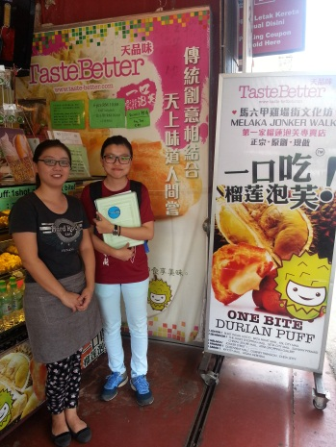

Figure : The Melaka durian puff owner and me

1. What is your occupation?

I am a food seller under Taste Better Company, which is popular with durian puff in Melaka.

1. What type of product you sell? Local or Non-local?

I sell the Melaka local food, called durian puff. I do sell the products of durian puff too.

1. How you promote your stuff?

I promote my stuff via books, YouTube video or my own websites.

1. How people know about your place?

Most of them know by searching from blog website or introduce by their tour guide if they follow by group.

1. If there is an application (system) for helping you to promote your product, will you want to use it?

Yes, I will.

1. What is the function that you think is required in the application (system)?

I suggest that you may add a function like the visitor can track my shop’s location, link with GPS for helping the visitor to know the location of my shop instead of asking or browsing here and there.

Second interviewee: Person B

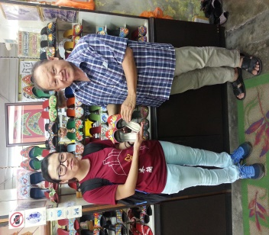

Figure : TS Lim Trading owner and me

1. What is your occupation?

I am a Baba Nyonya shoes seller at Melaka, all the shoes is 100% handmade by myself according to my design or customer request.

1. What type of product you sell? Local or Non-local?

Baba Nyonya shoes, it is a local product of Melaka.

1. How you promote your stuff?

I do not have any promotion on my stuff.

1. Any difficulties you faced when you promote your stuff?

I had use a website before to promote my stuff, but that involved a copyright problem, means my design had been stolen by other unknown people.

1. What is the main problem you faced when you sell your product?

The problem is most of the visitor do not know the traditional of Baba Nyonya. Most of my customer is the one who buys shoes from my shop frequently, I did not use any website or apps to update my customer’s order, I use the old technology, contact them by phone.

1. If there has an application (system) for helping you to promote your product, will you want to use it?

I will try to use the system, but not confident to use as I mentioned before, about my design copyright problem.

1. What is the function that you think is required in the application (system)?

I wish to have a function to view my product information and also my shop detail, for providing people the detail of about the traditional of Baba Nyonya instead of browsing through many sources.

## A2: Questionnaire Survey (Stakeholder => visitor/native)

**Instruction: Please tick (✓) the box that the best corresponds to your answer for each question below. Thank you for your willingness to assist us with this project.**

**Section A: Demographic Profile**

1. What is your gender?

* Female
* Male

1. What is your age?

* 17 years old and below
* 18 – 24 years old
* 24 – 31 years old
* 32 – 39 years old
* 40 years old and above

1. Are you a visitor?

* Yes
* No

1. How many days for your trip in Melaka?

* 2 days and below
* 3 days
* 4 days
* 5 days and above

**Section B: Visitor Experience**

**Please indicate your level of agreement or disagreement according to the following statements:**

|  |  |  |  |  |
| --- | --- | --- | --- | --- |
| **1** | **2** | **3** | **4** | **5** |
| **Strongly Disagree** | **Disagree** | **Neutral** | **Agree** | **Strongly Agree** |

|  |  |  |  |  |  |  |
| --- | --- | --- | --- | --- | --- | --- |
| No. | Statement | 1 | 2 | 3 | 4 | 5 |
| 1. | I always travel with group. |  |  |  |  |  |
| 2. | I am familiar with the local product at Melaka. |  |  |  |  |  |
| 3. | I always survey about the local product before traveling. |  |  |  |  |  |
| 4. | I always will buy the local product as souvenir in every trip. |  |  |  |  |  |
| 5. | I have enough time to buy the local product when traveling. |  |  |  |  |  |
| 6. | I have no difficulties on finding the shop that sells the local product. |  |  |  |  |  |

**Section C: System Overview**

1. The following table shows the overview of the proposed system that allow user to buy the local product by using smartphone. Please rate the needs of the function below:

|  |  |  |  |  |  |  |
| --- | --- | --- | --- | --- | --- | --- |
| No. | Basic Function | 1 | 2 | 3 | 4 | 5 |
| 1. | Login |  |  |  |  |  |
| 2. | Register |  |  |  |  |  |
| 3. | Order Product |  |  |  |  |  |
| 4. | View Order List |  |  |  |  |  |
| 5. | Online Payment |  |  |  |  |  |
| 6. | Search the local product |  |  |  |  |  |
| 7. | Bookmark the local product |  |  |  |  |  |
| 8. | View shop’s location |  |  |  |  |  |
| 9. | Rating on the product supplier |  |  |  |  |  |

1. What else function that is required in this application? Please leave your opinion below (optional): ________________________________________________________________________________________________________________________________________________________________________________________________________________________________________________________________________________

**Section D: User Behavior**

1. Which type of electronic device that you often use?

* Computer/ Laptop
* Smartphone
* Both

1. Which type of electronic device that you prefer the most for ordering the local product?

* Computer/ Laptop
* Smartphone
* Both

1. How you prefer to buy the favorite product?

* Delivery
* At the shop